Teddy Bears’ Picnic – Bear Ears

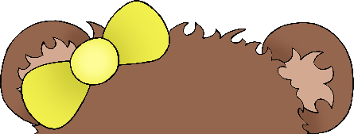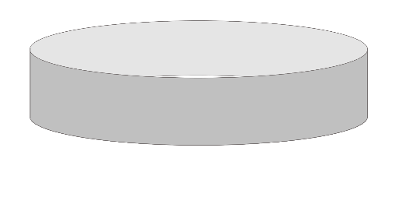

**3**

**2**

**1**

Cut out the desired ears and stick to the paper loop.

Wear the bear ears to the picnic!

Prepare a loop of paper to fit the child’s head.

© 2021 Little Owls Resources

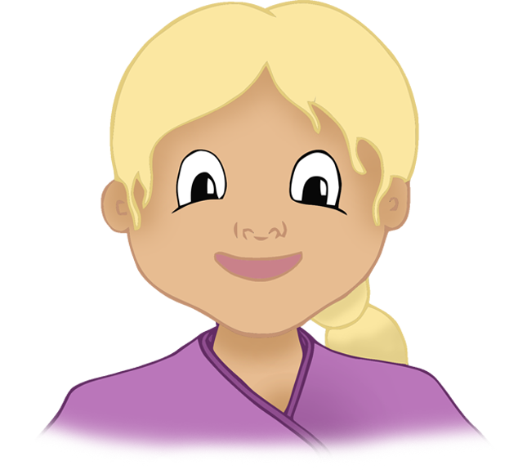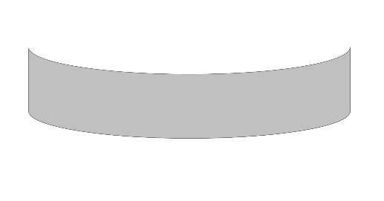

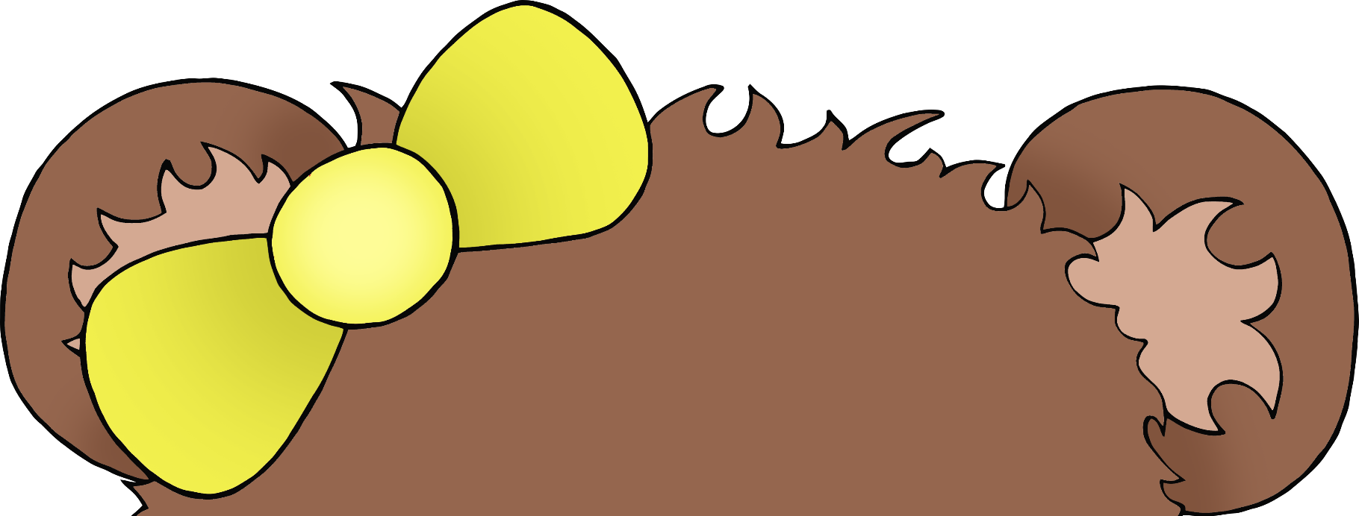

© 2021 Little Owls Resources

© 2021 Little Owls Resources

© 2021 Little Owls Resources

© 2021 Little Owls Resources