Teddy Bears’ Picnic – Bear Ears (Colouring)

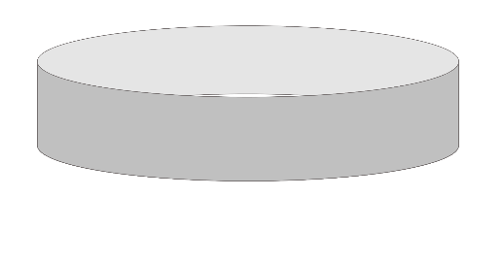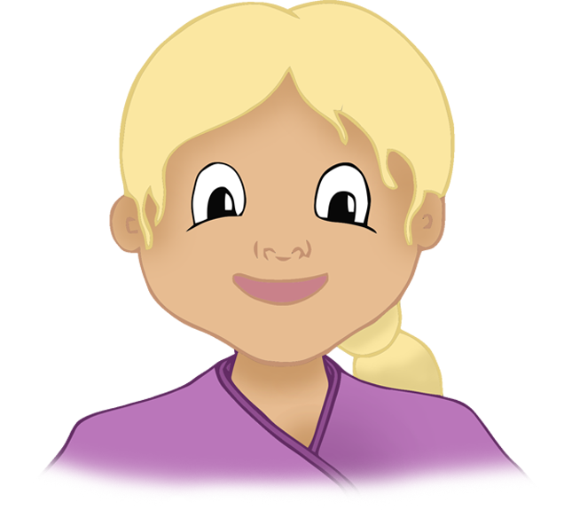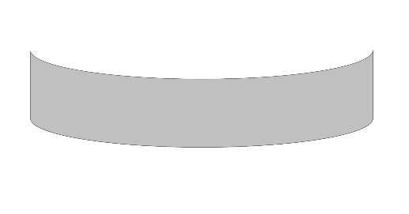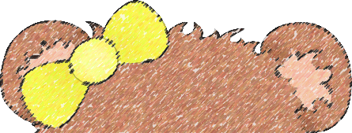

© 2021 Little Owls Resources

Prepare a loop of paper to fit the child’s head.

Colour and cut out the desired ears and stick to the paper loop.

Wear the bear ears to the picnic!

**1**

**2**

**3**

© 2021 Little Owls Resources

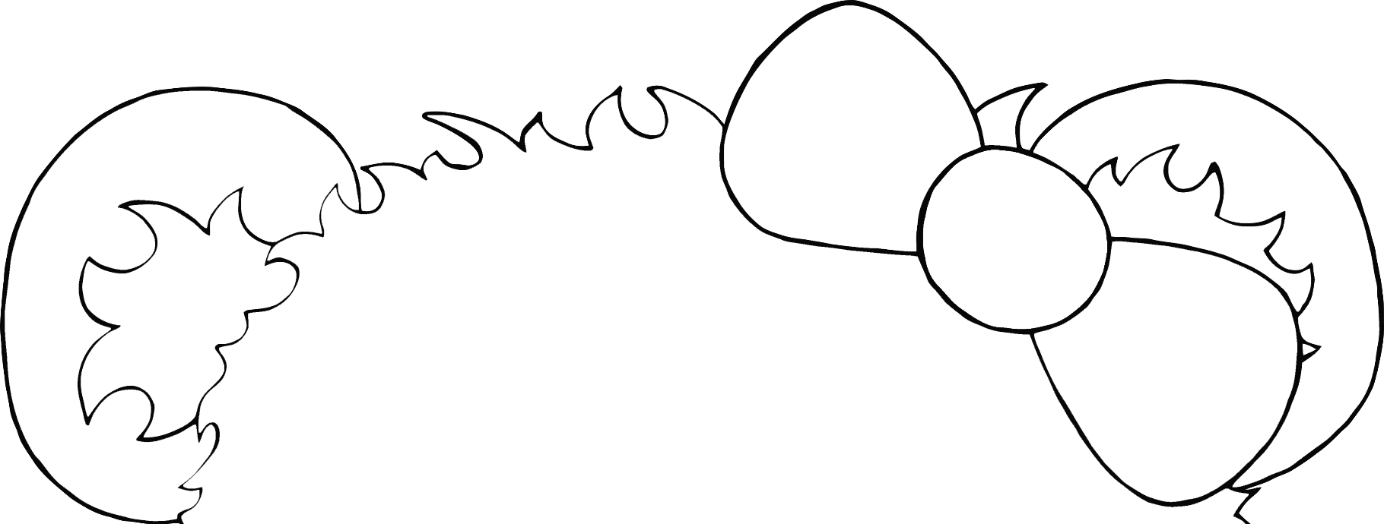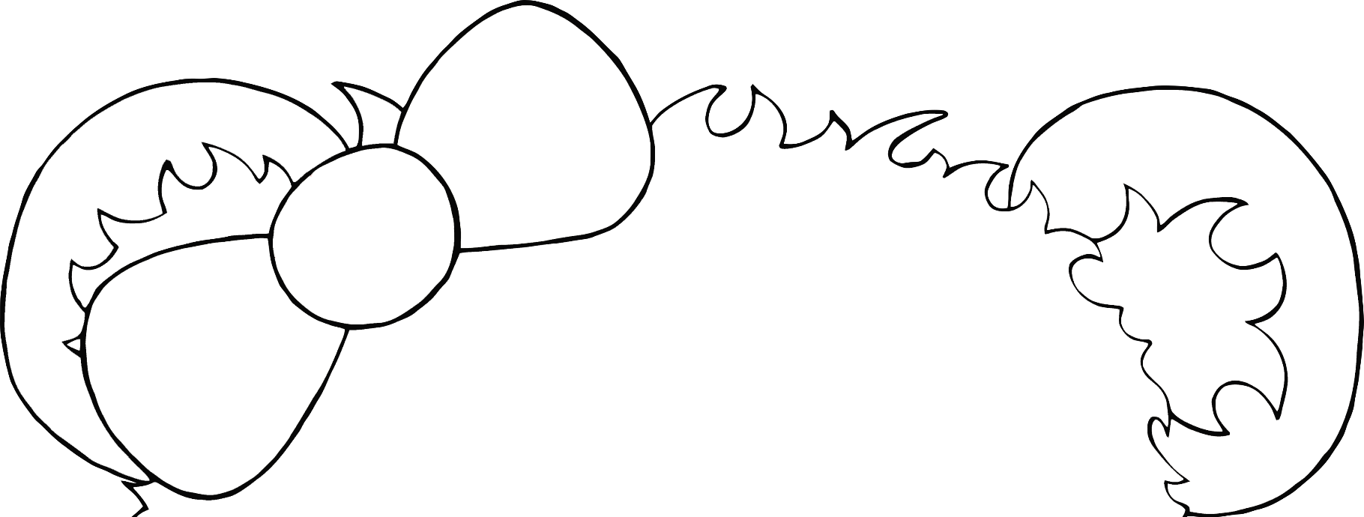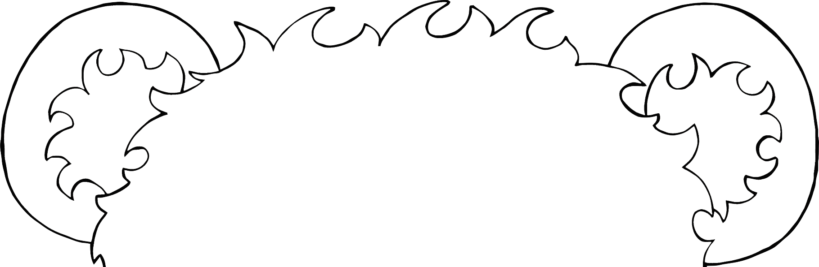

© 2021 Little Owls Resources