Beach Scavenger Hunt

Checklists

These checklists are to promote mindfulness and awareness of surroundings when in a beach setting.

This activity is intended to help children engage their senses to better notice and appreciate the environment around them.

© 2021 Little Owls Resources

© 2022 Little Owls Resources

Can you find...?

Something on a rock

A bird

Something you can smell

Something you can hold with one hand

Something you have never seen before

Something brown

Something that makes a sound

A tiny animal

A pebble

Beach Scavenger Hunt



?

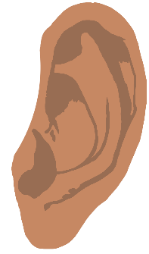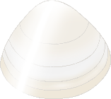

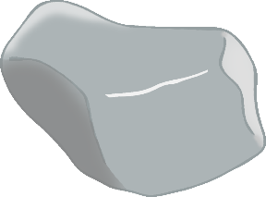

© 2022 Little Owls Resources

An animal with a hard shell

A fossil

Something delicate

Something yellow/orange

A mermaid’s purse (Egg case)

Something very small

Something that moves

Something that grows

A rockpool



Beach Scavenger Hunt

Can you find...?

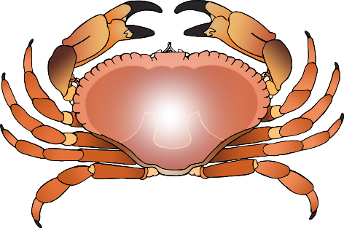



Beach Scavenger Hunt

Can you draw...?

© 2022 Little Owls Resources

Bird

Seaweed

Stone/Pebble

Large shell

Minibeast

Sea animal

Waves

Small shell

Rockpool