These cards can be laminated for repeated use. Each of the six beach animals has a dotted line card and a card with a blank space.

**Beach Mark Making Cards**

© 2022 Little Owls Resources

© 2021 Little Owls Resources

© 2022 Little Owls Resources

© 2022 Little Owls Resources

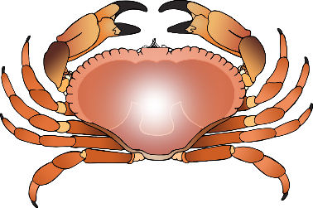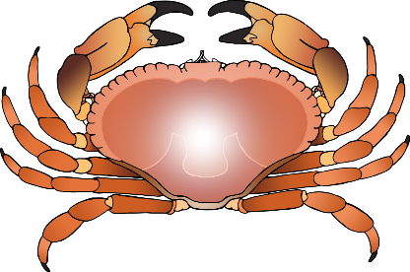

© 2022 Little Owls Resources

© 2022 Little Owls Resources

© 2022 Little Owls Resources

© 2022 Little Owls Resources

© 2022 Little Owls Resources

© 2022 Little Owls Resources

© 2022 Little Owls Resources

© 2022 Little Owls Resources

© 2022 Little Owls Resources

© 2022 Little Owls Resources