**Bat**

The pages of this pack give some general information about bats and some fun and engaging activities to foster and develop children’s interest in them.

**This pack includes:**

* Fact posters x3 (Could be used as stimuli for a lesson input)
* Number slice activity (1-10) (Can be pre-cut for a pure number ordering activity or left to be cut by child to add scissor practice)
* Number slice activity - colouring version (1-10) (As above but to be coloured before cutting)
* Description sheet (Can be used as an independent writing activity or with an adult scribing the ideas of a younger child)
* A4 poster
* A4 poster - colouring version
* ‘Body Parts’ x3 (fully labelled, initial sounds only, blank)
* Draw and write sheets x3 (blank sheet, wide lines and narrow lines)
* 1x 4-piece puzzle
* Multimats x2 (for Colouring/Art & Craft/Loose Parts/Playdough)

© 2021 Little Owls Resources

This pack includes:

The pages of this pack give some general information about the role of a paramedic and some fun and engaging activities to foster and develop children’s interest in this role in society.

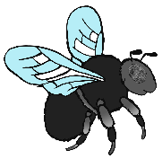

© 2021 Little Owls Resources

**Bat Facts**

Bats usually live for

years.

**4-5**

Bats eat **insects**.

Bats are the only mammal that can fly.

**Bats are** Protected.

Climate change affects insects which the bats need to eat.

Humans have destroyed lots of places in which bats make their homes.

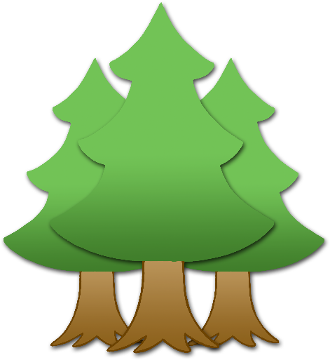

© 2021 Little Owls Resources

**How big is a Bat?**

7 – 8 cm

© 2021 Little Owls Resources

1

2

3

4

5

6

7

8

9

10

© 2021 Little Owls Resources

© 2021 Little Owls Resources

1

2

3

4

5

6

7

8

9

10

© 2021 Little Owls Resources

**What words would you use to describe a bat?**

**Bat**

© 2021 Little Owls Resources

**Bat**

© 2021 Little Owls Resources

**Bat body parts**

© 2021 Little Owls Resources

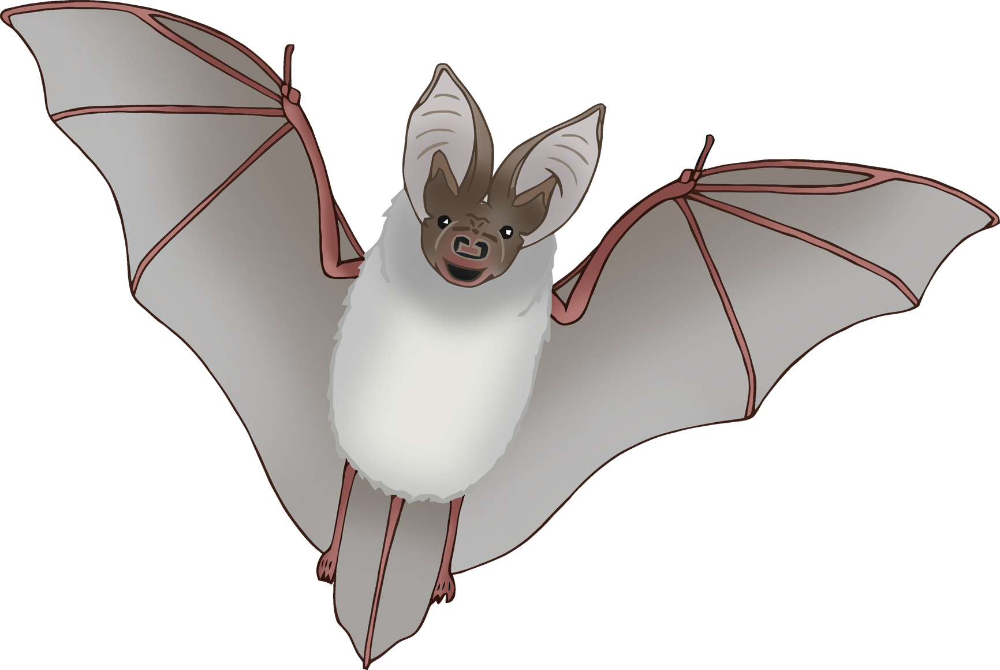

ear

**w**ing

mouth

leg

tail

**Bat body parts**

© 2021 Little Owls Resources



e

**w**

m

l

t

**Bat body parts**

© 2021 Little Owls Resources



© 2021 Little Owls Resources

**Draw a Bat!**

© 2021 Little Owls Resources

**Draw and write about a Bat!**

____________________________________________________

© 2021 Little Owls Resources

**Draw and write about a Bat!**

______________________________________________________________________________________________________

**Bat**

© 2021 Little Owls Resources

© 2021 Little Owls Resources

**Bat Multimat - Bat**

© 2021 Little Owls Resources

**Bat Multimat - Bats**

