**Decorate a Badger!**

© 2020 Little Owls Resources

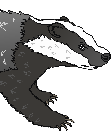

**Decorate a Badger!**

© 2020 Little Owls Resources

