puppy

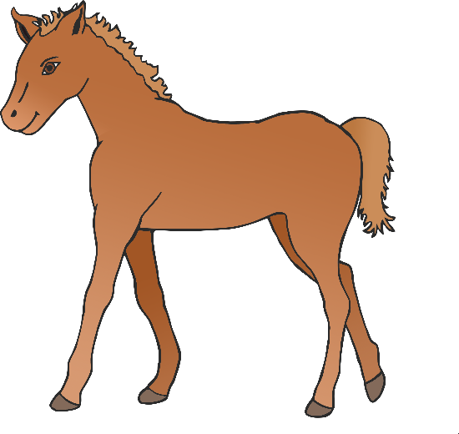

foal

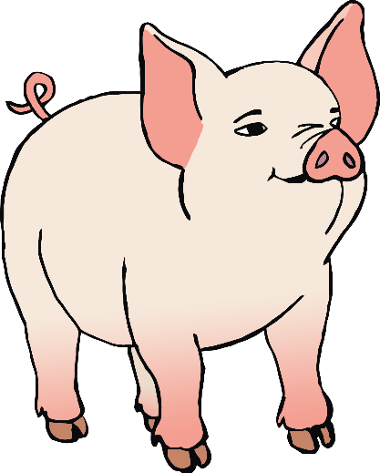

(horse)

© 2021 Little Owls Resources

© 2021 Little Owls Resources

piglet

© 2021 Little Owls Resources

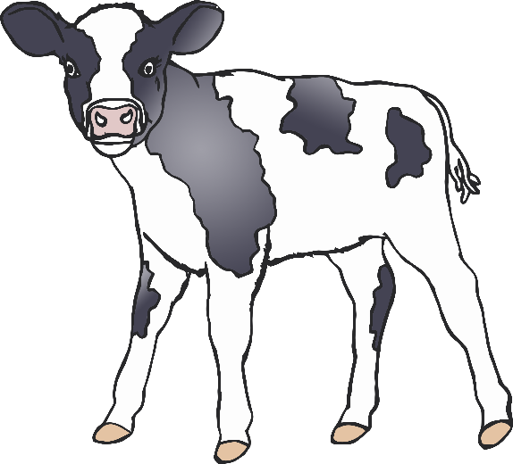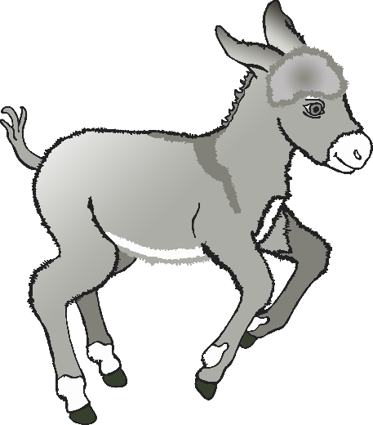

(donkey)

foal

calf

kid

© 2021 Little Owls Resources

© 2021 Little Owls Resources

© 2021 Little Owls Resources

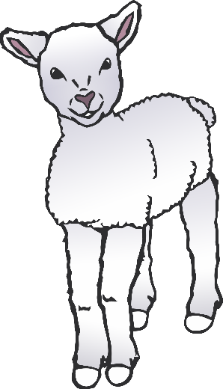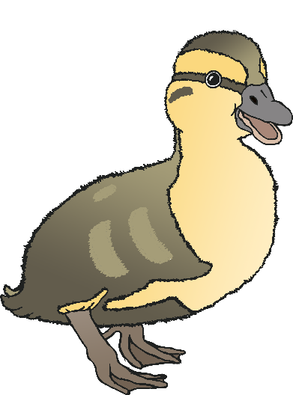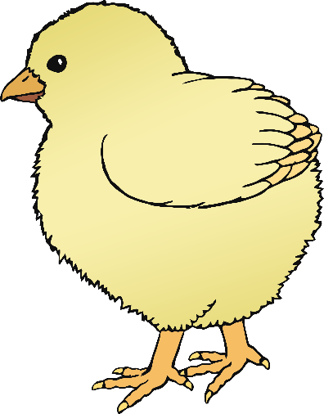

duckling

chick

lamb

© 2021 Little Owls Resources

© 2021 Little Owls Resources

© 2021 Little Owls Resources

gosling

© 2021 Little Owls Resources

© 2021 Little Owls Resources

© 2021 Little Owls Resources