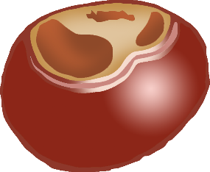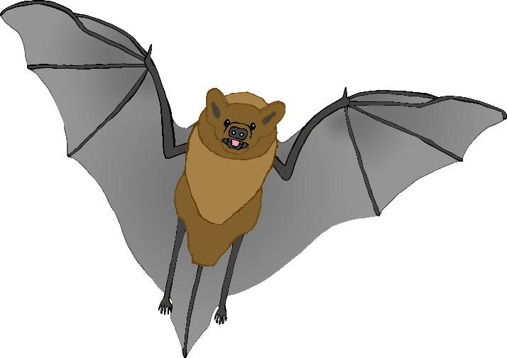

acorn

bat

conkers

© 2022 Little Owls Resources

© 2022 Little Owls Resources

© 2022 Little Owls Resources

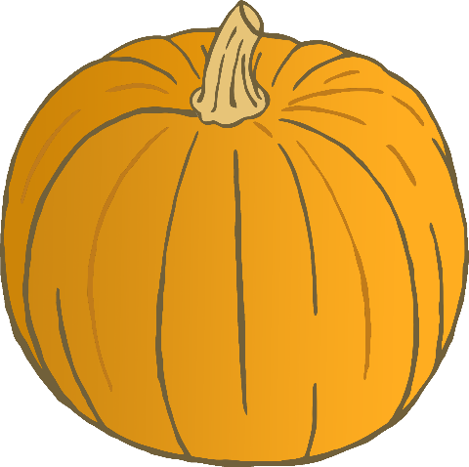

fox

hedgehog

pumpkin

© 2022 Little Owls Resources

© 2022 Little Owls Resources

© 2022 Little Owls Resources

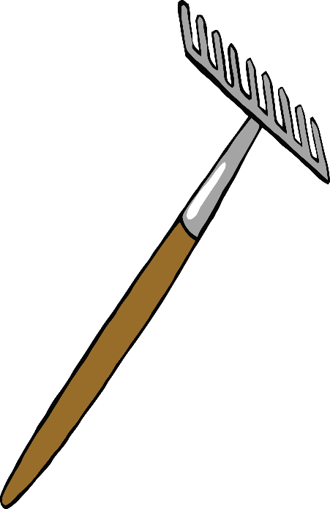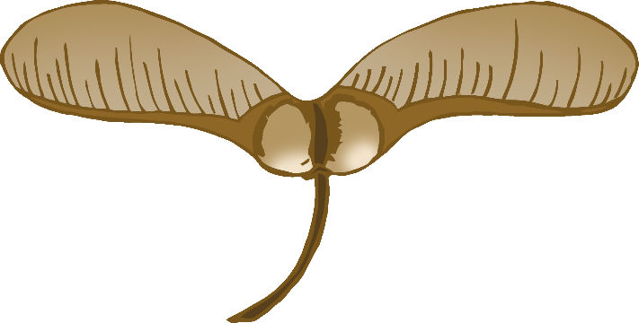

rake

squirrel

sycamore seeds

© 2022 Little Owls Resources

© 2022 Little Owls Resources

© 2022 Little Owls Resources

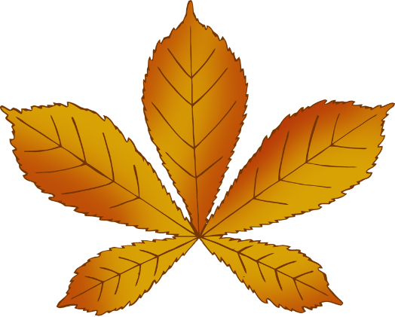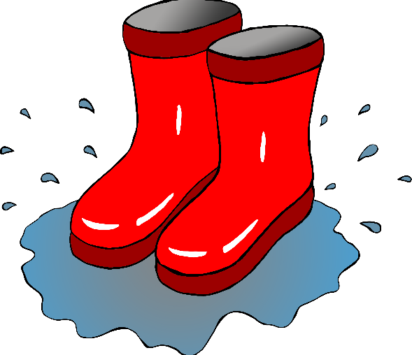

wellies

leaf

leaves

© 2022 Little Owls Resources

© 2022 Little Owls Resources

© 2022 Little Owls Resources

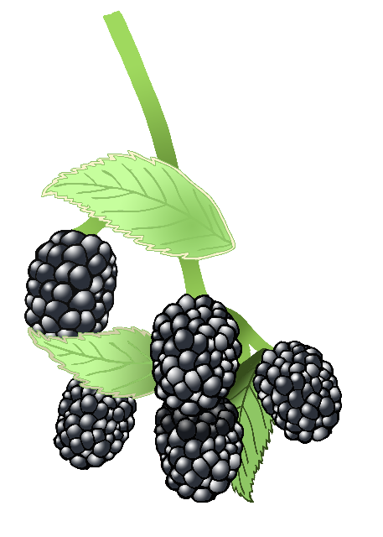

blackberries

fungus

fungus

© 2022 Little Owls Resources

© 2022 Little Owls Resources

© 2022 Little Owls Resources

orange

brown

red

© 2022 Little Owls Resources

© 2022 Little Owls Resources

© 2022 Little Owls Resources

yellow

rain

sun

© 2022 Little Owls Resources

© 2022 Little Owls Resources

© 2022 Little Owls Resources

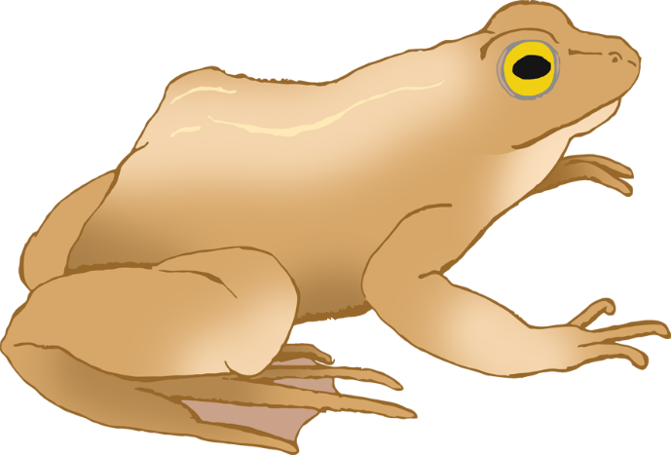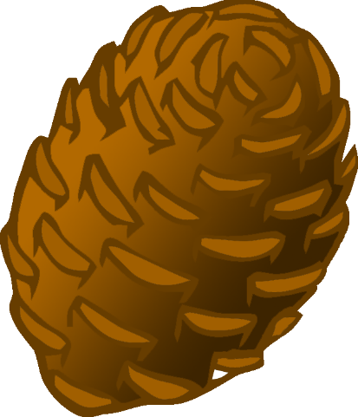

frog

pine cone

clouds

© 2022 Little Owls Resources

© 2022 Little Owls Resources

© 2022 Little Owls Resources

wind

worm

bumblebee

© 2022 Little Owls Resources

© 2022 Little Owls Resources

© 2022 Little Owls Resources

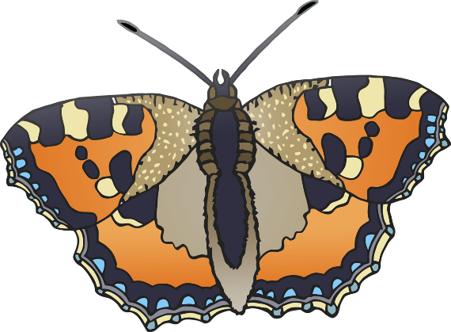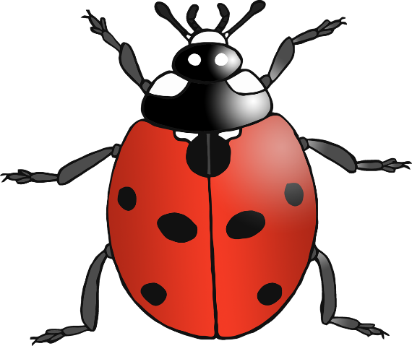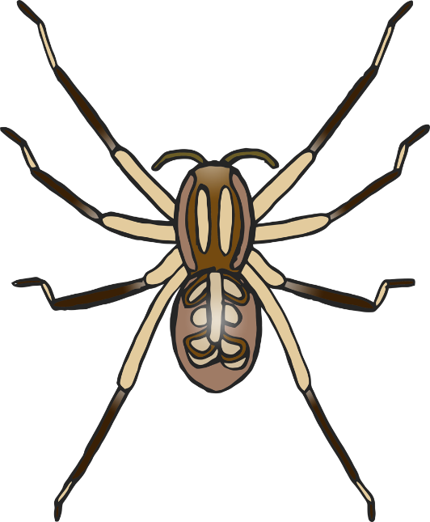

spider

ladybird

butterfly

© 2022 Little Owls Resources

© 2022 Little Owls Resources

© 2022 Little Owls Resources

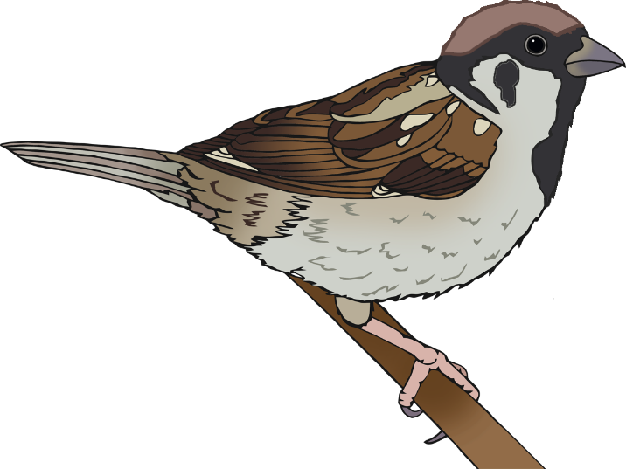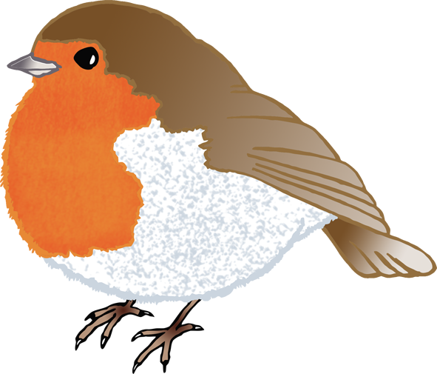

robin

blue tit

sparrow

© 2022 Little Owls Resources

© 2022 Little Owls Resources

© 2022 Little Owls Resources

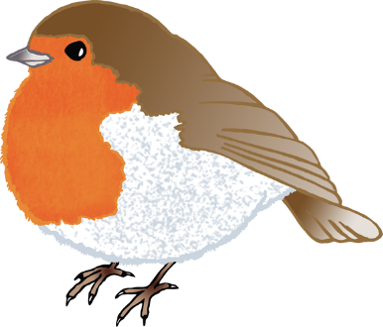

blackbird

birds

trees

© 2022 Little Owls Resources

© 2022 Little Owls Resources

© 2022 Little Owls Resources

woolly hat

cardigan

gloves

© 2022 Little Owls Resources

© 2022 Little Owls Resources

© 2022 Little Owls Resources

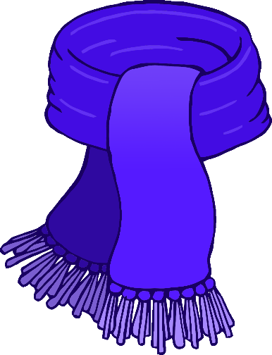

scarf

coat

jacket

© 2022 Little Owls Resources

© 2022 Little Owls Resources

© 2022 Little Owls Resources

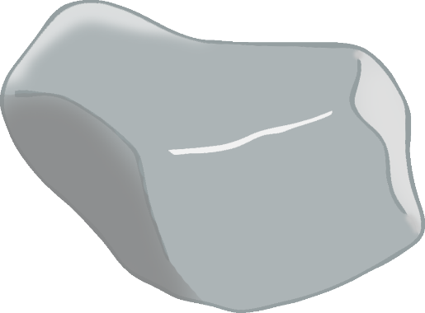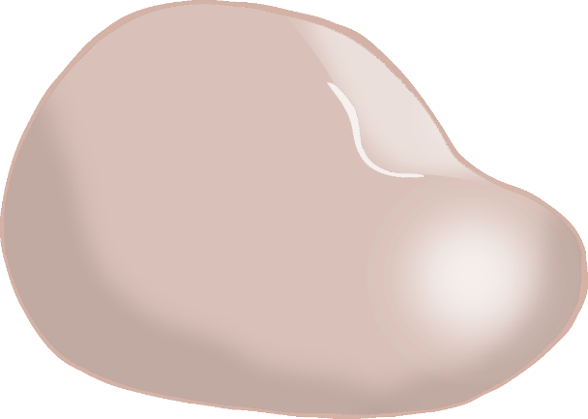

mud

stones

stick

© 2022 Little Owls Resources

© 2022 Little Owls Resources

© 2022 Little Owls Resources

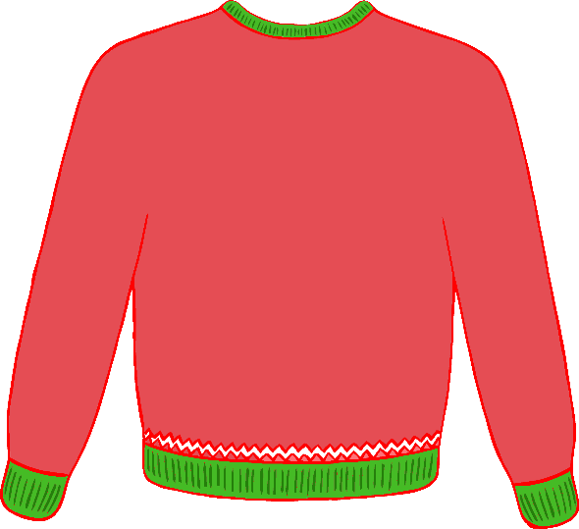

jumper

puddle

wet

© 2022 Little Owls Resources

© 2022 Little Owls Resources

© 2022 Little Owls Resources