Subitising

Large flash cards (A4)

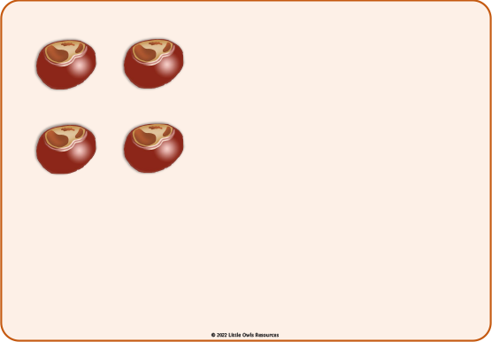

The children are to be encouraged to say how many dots there are straight away with no counting. They are intended to be held up by an adult as part of a group or class activity.

© 2022 Little Owls Resources

© 2022 Little Owls Resources

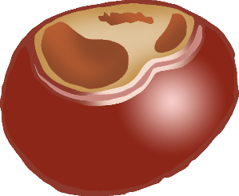



© 2022 Little Owls Resources



© 2022 Little Owls Resources



© 2022 Little Owls Resources



© 2022 Little Owls Resources



© 2022 Little Owls Resources



© 2022 Little Owls Resources



© 2022 Little Owls Resources



© 2022 Little Owls Resources



© 2022 Little Owls Resources



© 2022 Little Owls Resources



© 2022 Little Owls Resources



© 2022 Little Owls Resources



© 2022 Little Owls Resources



© 2022 Little Owls Resources



© 2022 Little Owls Resources



© 2022 Little Owls Resources



© 2022 Little Owls Resources



© 2022 Little Owls Resources



© 2022 Little Owls Resources



© 2022 Little Owls Resources



© 2022 Little Owls Resources

© 2022 Little Owls Resources