Fold along here

‘Turn and check’ cards (A6)

The children are to be encouraged to say how many dots there are straight away with no counting. They could use these independently and self-check or the cards could be held up by an adult as part of a group activity.

*These cards are to be cut and folded along the middle and then laminated to make a longer lasting resource.*

Subitising

© 2022 Little Owls Resources

© 2022 Little Owls Resources

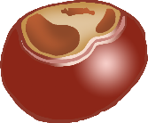

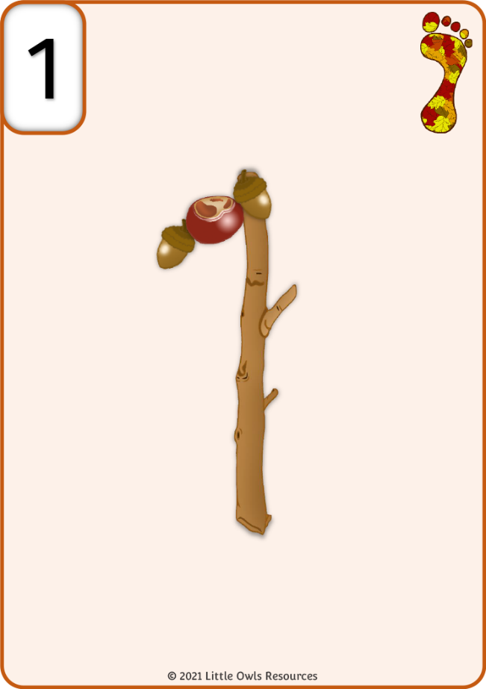



© 2022 Little Owls Resources

© 2022 Little Owls Resources

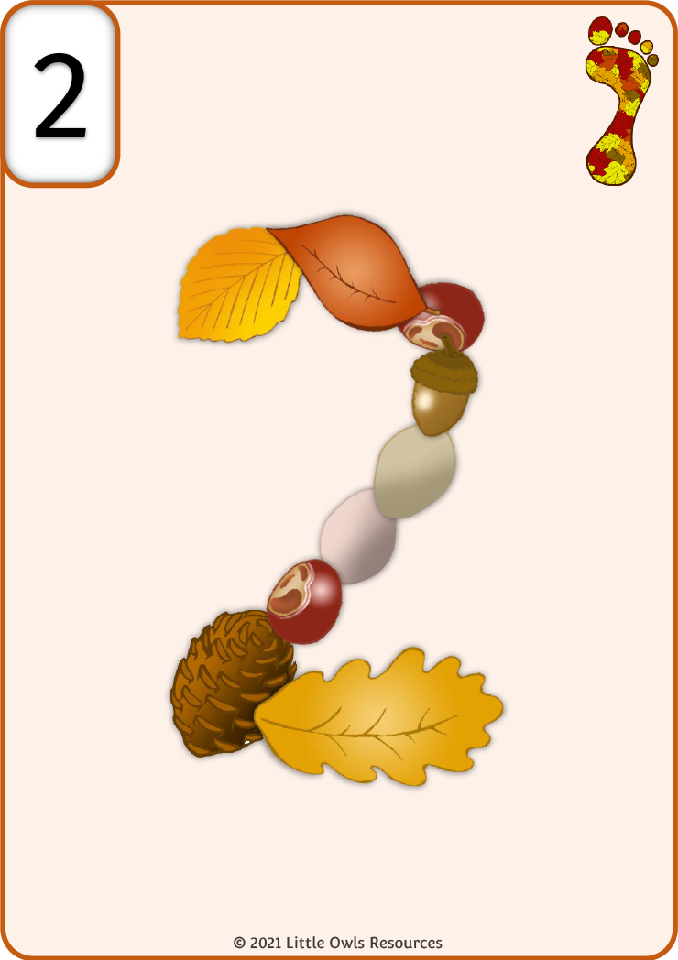



© 2022 Little Owls Resources

© 2022 Little Owls Resources





© 2022 Little Owls Resources

© 2022 Little Owls Resources

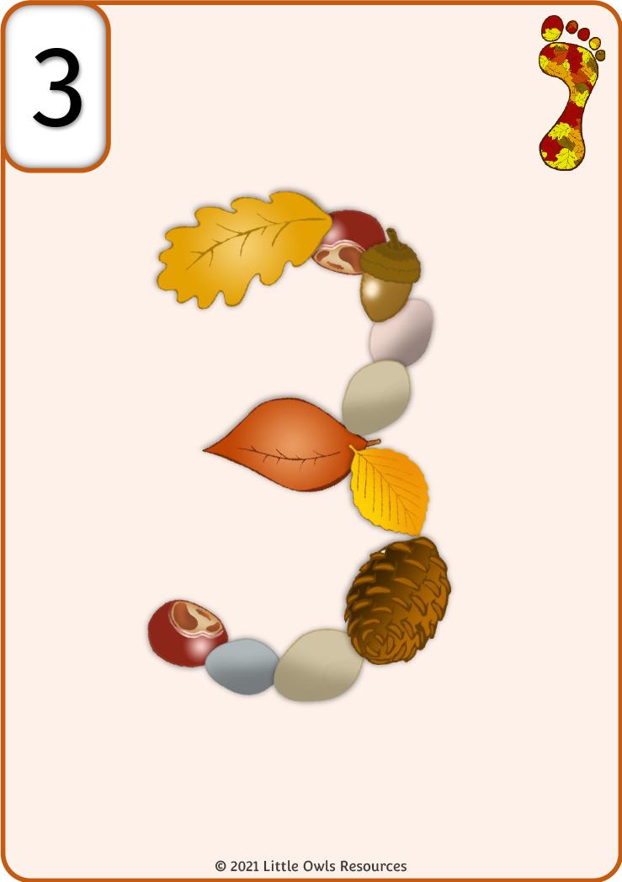



© 2022 Little Owls Resources

© 2022 Little Owls Resources





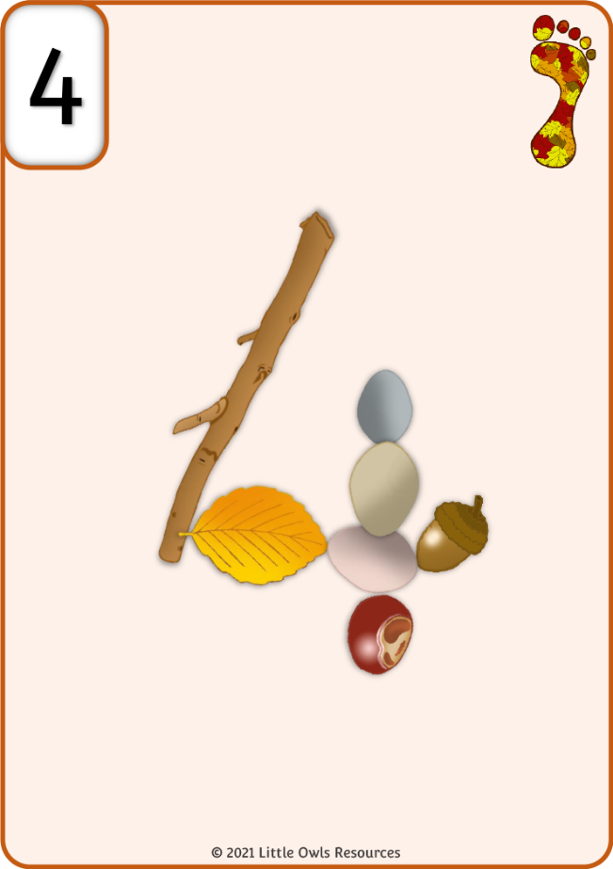

© 2022 Little Owls Resources

© 2022 Little Owls Resources

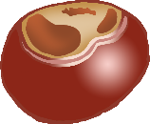



© 2022 Little Owls Resources

© 2022 Little Owls Resources



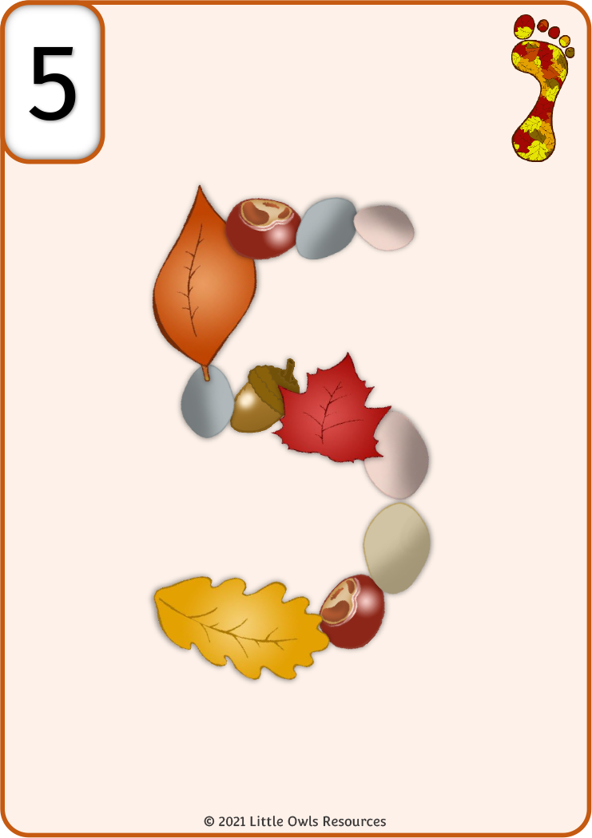

© 2022 Little Owls Resources

© 2022 Little Owls Resources





© 2022 Little Owls Resources

© 2022 Little Owls Resources



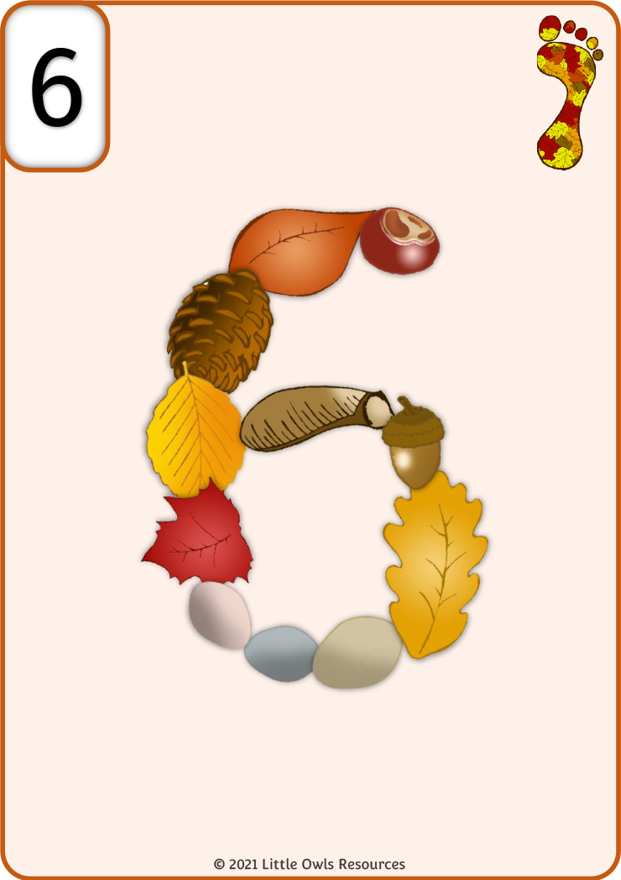

© 2022 Little Owls Resources

© 2022 Little Owls Resources





© 2022 Little Owls Resources

© 2022 Little Owls Resources

© 2022 Little Owls Resources

© 2022 Little Owls Resources