**Autumn Word Mat**

© 2022 Little Owls Resources

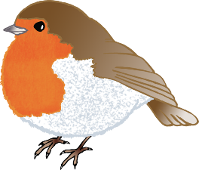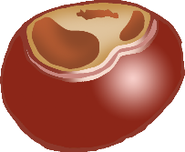

trees

gloves

stick

jumper

birds

worm

puddle

squirrel

rain

leaves

conkers

acorn