**Autumn Walk Checklist** ✔️✔️✔️

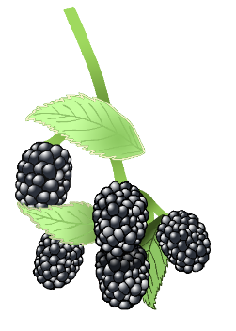

© 2020 Little Owls Resources

**Autumn Walk Checklist** ✔️✔️✔️

leaves

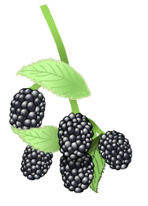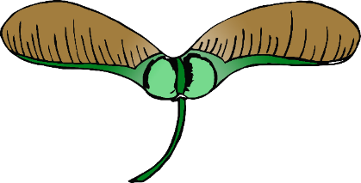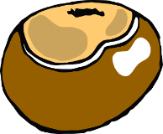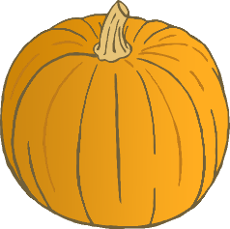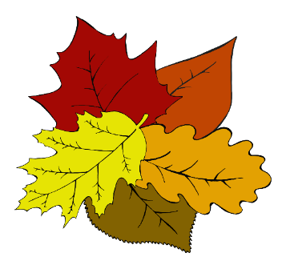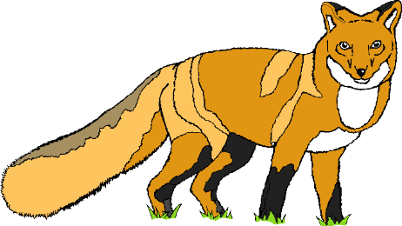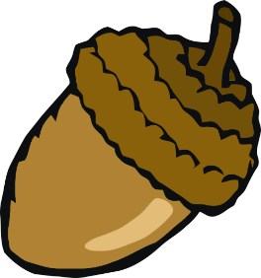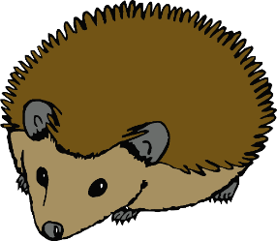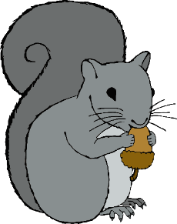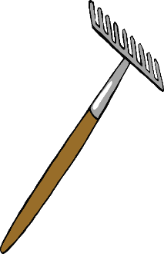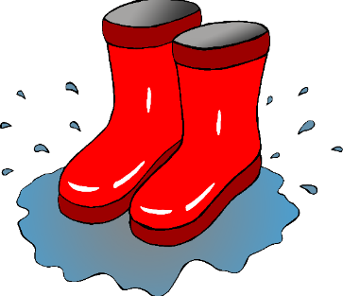

acorn

hedgehog

pine cone

squirrel

brown leaf

yellow leaf

conker

orange leaf

red leaf

fungus

sycamore seeds

blackberries

© 2020 Little Owls Resources

conker

sycamore seeds

pumpkin

fox

acorn

hedgehog

squirrel

rake

fungus

blackberries

wellies