**Autumn Senses Prompts**

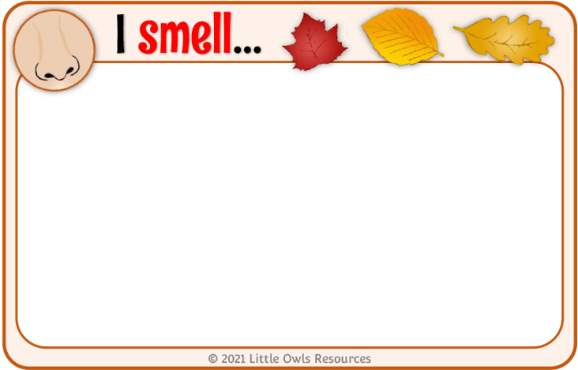

mud

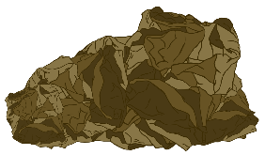

These prompts are intended to encourage discussion and thinking about our senses during the autumn.

Together with each mini-banner there are small note sheets for children to mark-make/write/draw their thoughts and experiences.

© 2021 Little Owls Resources

© 2020 Little Owls Resources

**Senses**

© 2021 Little Owls Resources

What can you smell?

© 2021 Little Owls Resources

I smell…



© 2021 Little Owls Resources

I smell…



**Autumn**

© 2021 Little Owls Resources

I smell…



© 2021 Little Owls Resources

I smell…



© 2021 Little Owls Resources

I smell…



© 2021 Little Owls Resources

I smell…



**Senses**

© 2021 Little Owls Resources

What can you see?

© 2021 Little Owls Resources

I see…



© 2021 Little Owls Resources

I see…

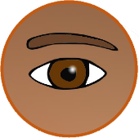

**Autumn**

© 2021 Little Owls Resources

I see…



© 2021 Little Owls Resources

I see…



© 2021 Little Owls Resources

I see…



© 2021 Little Owls Resources

I see…



**Senses**

© 2021 Little Owls Resources

What can you hear?

© 2021 Little Owls Resources

I hear…



© 2021 Little Owls Resources

I hear…

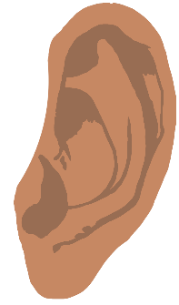

**Autumn**

© 2021 Little Owls Resources

I hear…



© 2021 Little Owls Resources

I hear…



© 2021 Little Owls Resources

I hear…



© 2021 Little Owls Resources

I hear…



**Senses**

© 2021 Little Owls Resources

What can you feel?

© 2021 Little Owls Resources

I feel…



© 2021 Little Owls Resources

I feel…



**Autumn**

© 2021 Little Owls Resources

I feel…



© 2021 Little Owls Resources

I feel…



© 2021 Little Owls Resources

I feel…



© 2021 Little Owls Resources

I feel…



**Senses**

© 2021 Little Owls Resources

What can you taste?

© 2021 Little Owls Resources

I taste…



© 2021 Little Owls Resources

I taste…

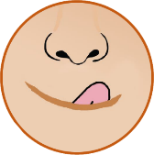

**Autumn**

© 2021 Little Owls Resources

I taste…



© 2021 Little Owls Resources

I taste…



© 2021 Little Owls Resources

I taste…



© 2021 Little Owls Resources

I taste…

