www.littleowlsresources.com

© 2019 Little Owls Resources

www.littleowlsresources.com

© 2019 Little Owls Resources

acorn

acorn

www.littleowlsresources.com

© 2019 Little Owls Resources

www.littleowlsresources.com

© 2019 Little Owls Resources

acorn

acorn

www.littleowlsresources.com

© 2019 Little Owls Resources

www.littleowlsresources.com

© 2019 Little Owls Resources

fox

fox

www.littleowlsresources.com

© 2019 Little Owls Resources

www.littleowlsresources.com

© 2019 Little Owls Resources

fox

fox

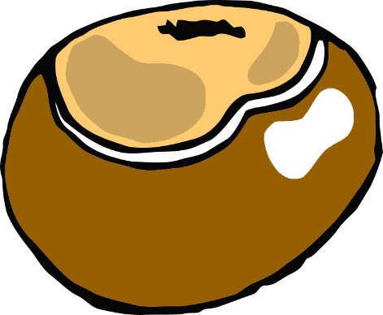

www.littleowlsresources.com

© 2019 Little Owls Resources

conker

conker

www.littleowlsresources.com

© 2019 Little Owls Resources





www.littleowlsresources.com

© 2019 Little Owls Resources

conker

conker

www.littleowlsresources.com

© 2019 Little Owls Resources



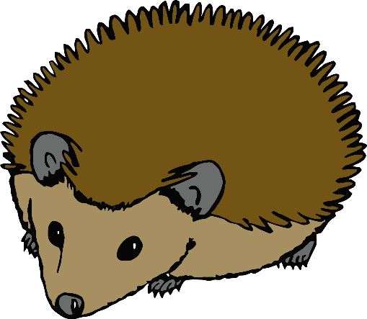

www.littleowlsresources.com

© 2019 Little Owls Resources

hedgehog

hedgehog

www.littleowlsresources.com

© 2019 Little Owls Resources



www.littleowlsresources.com

© 2019 Little Owls Resources

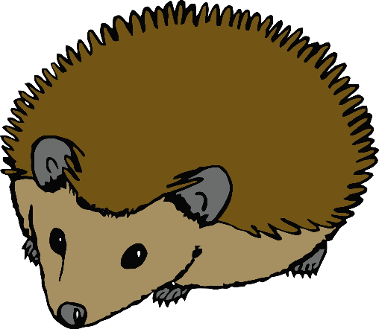

hedgehog

hedgehog

www.littleowlsresources.com

© 2019 Little Owls Resources

www.littleowlsresources.com

© 2019 Little Owls Resources

www.littleowlsresources.com

© 2019 Little Owls Resources

leaves

leaves

www.littleowlsresources.com

© 2019 Little Owls Resources

www.littleowlsresources.com

© 2019 Little Owls Resources

leaves

leaves

www.littleowlsresources.com

© 2019 Little Owls Resources

www.littleowlsresources.com

© 2019 Little Owls Resources

squirrels

squirrels

www.littleowlsresources.com

© 2019 Little Owls Resources

www.littleowlsresources.com

© 2019 Little Owls Resources

squirrels

squirrels

www.littleowlsresources.com

© 2019 Little Owls Resources

sycamore seeds

sycamore seeds

www.littleowlsresources.com

© 2019 Little Owls Resources

www.littleowlsresources.com

© 2019 Little Owls Resources

sycamore seeds

sycamore seeds

www.littleowlsresources.com

© 2019 Little Owls Resources

www.littleowlsresources.com

© 2019 Little Owls Resources

www.littleowlsresources.com

© 2019 Little Owls Resources

rake

rake

www.littleowlsresources.com

© 2019 Little Owls Resources

www.littleowlsresources.com

© 2019 Little Owls Resources

rake

rake

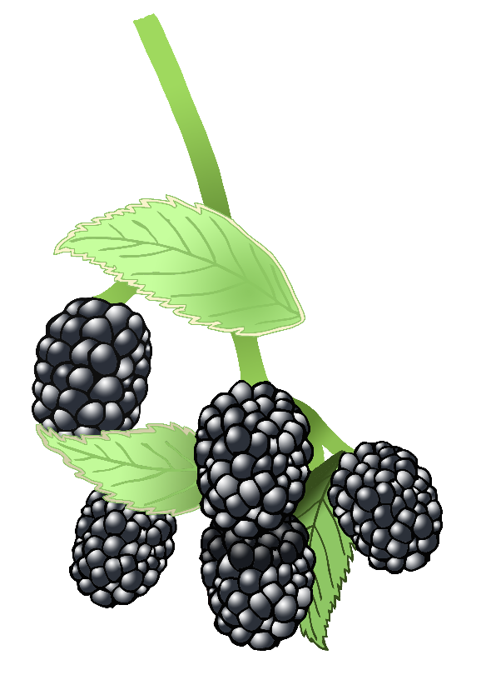

blackberries

blackberries

www.littleowlsresources.com

© 2019 Little Owls Resources



www.littleowlsresources.com

© 2019 Little Owls Resources



www.littleowlsresources.com

© 2019 Little Owls Resources



www.littleowlsresources.com

© 2019 Little Owls Resources

blackberries

blackberries

www.littleowlsresources.com

© 2019 Little Owls Resources

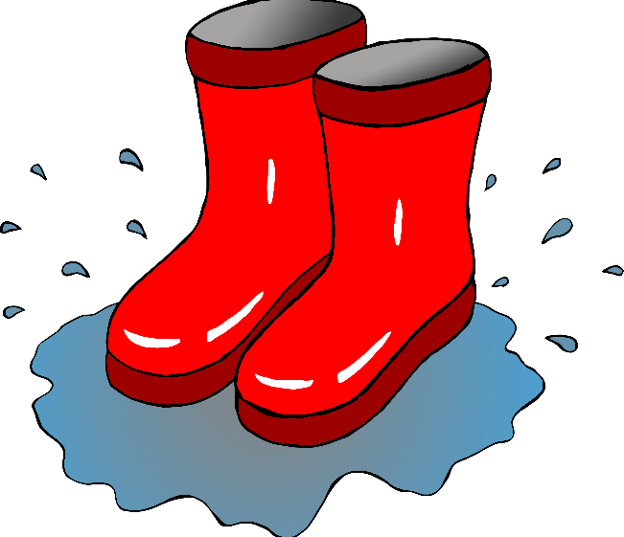

www.littleowlsresources.com

© 2019 Little Owls Resources

splashing in puddles

splashing in puddles

www.littleowlsresources.com

© 2019 Little Owls Resources

splashing in puddles

splashing in puddles



www.littleowlsresources.com

© 2019 Little Owls Resources

www.littleowlsresources.com

© 2019 Little Owls Resources

fungus

fungus

www.littleowlsresources.com

© 2019 Little Owls Resources

www.littleowlsresources.com

© 2019 Little Owls Resources

www.littleowlsresources.com

© 2019 Little Owls Resources

fungus

fungus