**Autumn Leaf Symmetry**

© 2021 Little Owls Resources

**Draw the rest of the leaf!**

**Autumn Leaf Symmetry**

© 2021 Little Owls Resources

**Draw the rest of the leaf!**

**Autumn Leaf Symmetry**

© 2021 Little Owls Resources

**Draw the rest of the leaf!**

**Autumn Leaf Symmetry**

© 2021 Little Owls Resources

**Draw the rest of the leaf!**

**Autumn Leaf Symmetry**

**Draw the rest of the leaf!**

© 2021 Little Owls Resources

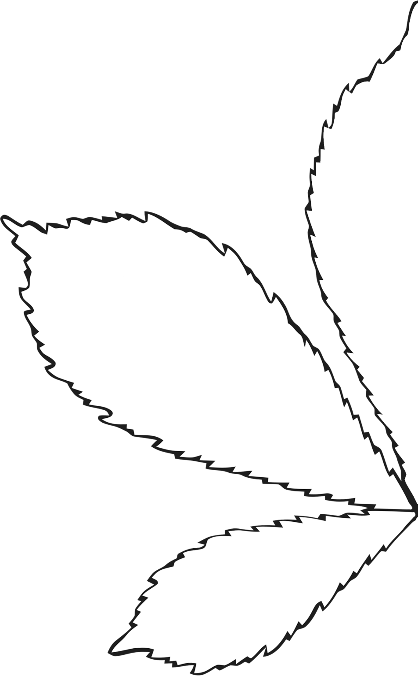

**Autumn Leaf Symmetry**

**Draw the rest of the leaf!**

© 2021 Little Owls Resources