**Decorate an Autumn Leaf!**

© 2020 Little Owls Resources

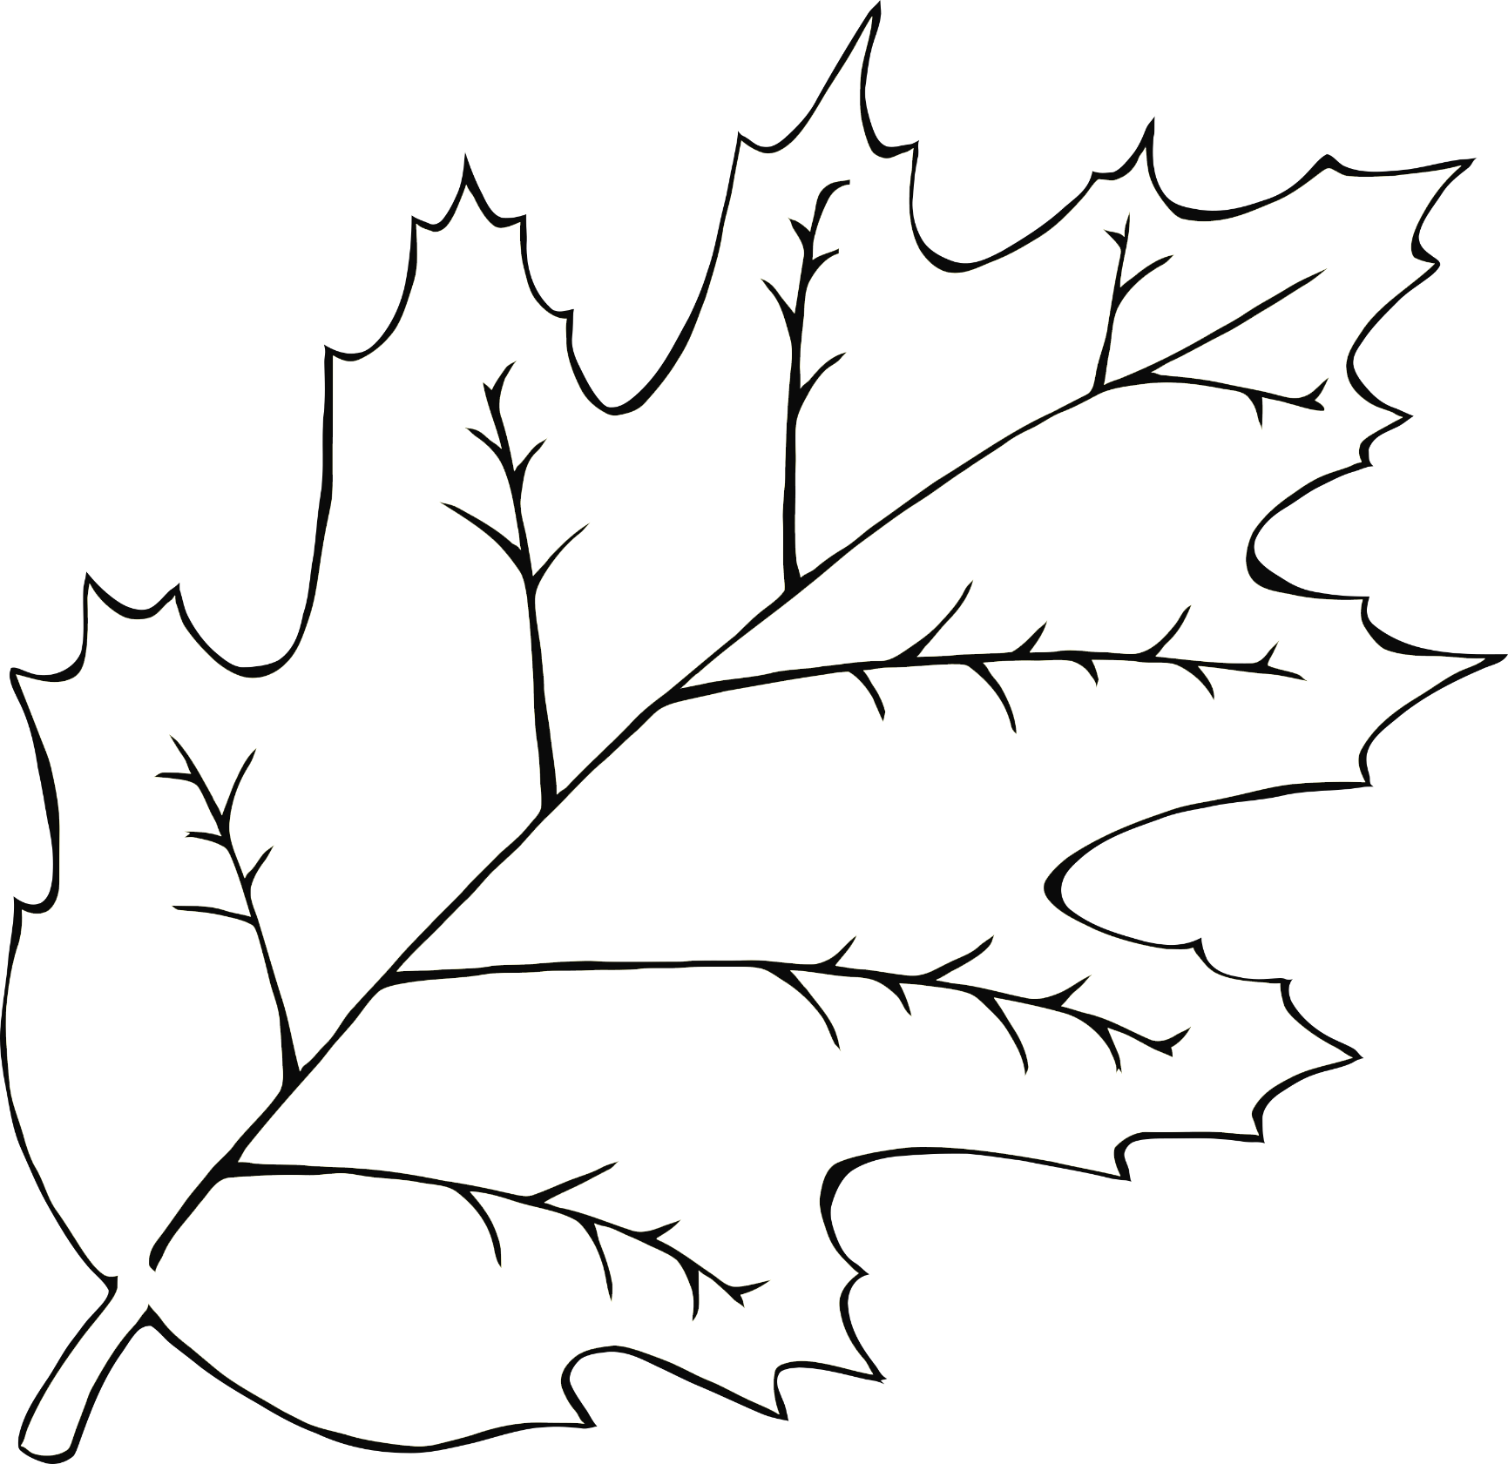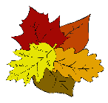

**Decorate an Autumn Leaf!**

© 2020 Little Owls Resources

