**Autumn Leaf Display**

Leaf outlines

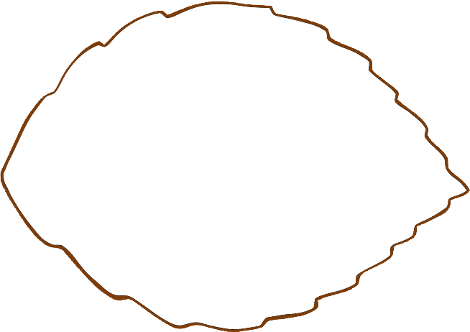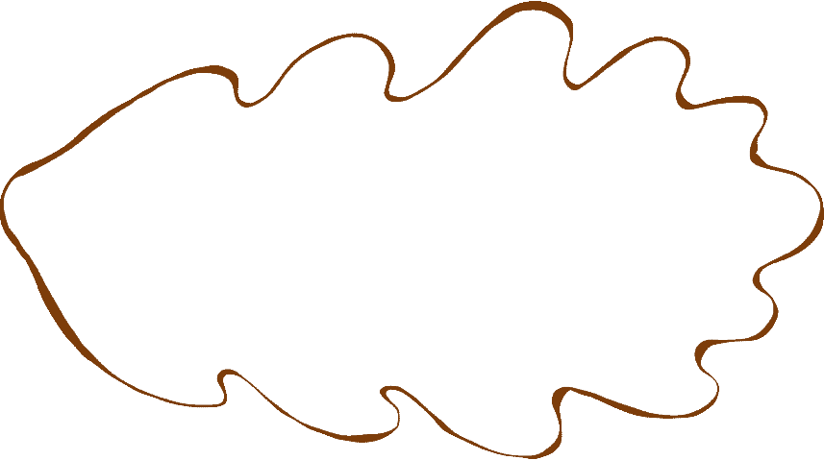

These leaves can be used by the children to draw and/or write on with the goal of creating a group display.

For example, a kindness display could be created by the children drawing/writing on their leaves about kind things others have done for them, or that they have done for others.

The cutting out of the leaves also helps as fine motor practice.

© 2021 Little Owls Resources

© 2021 Little Owls Resources

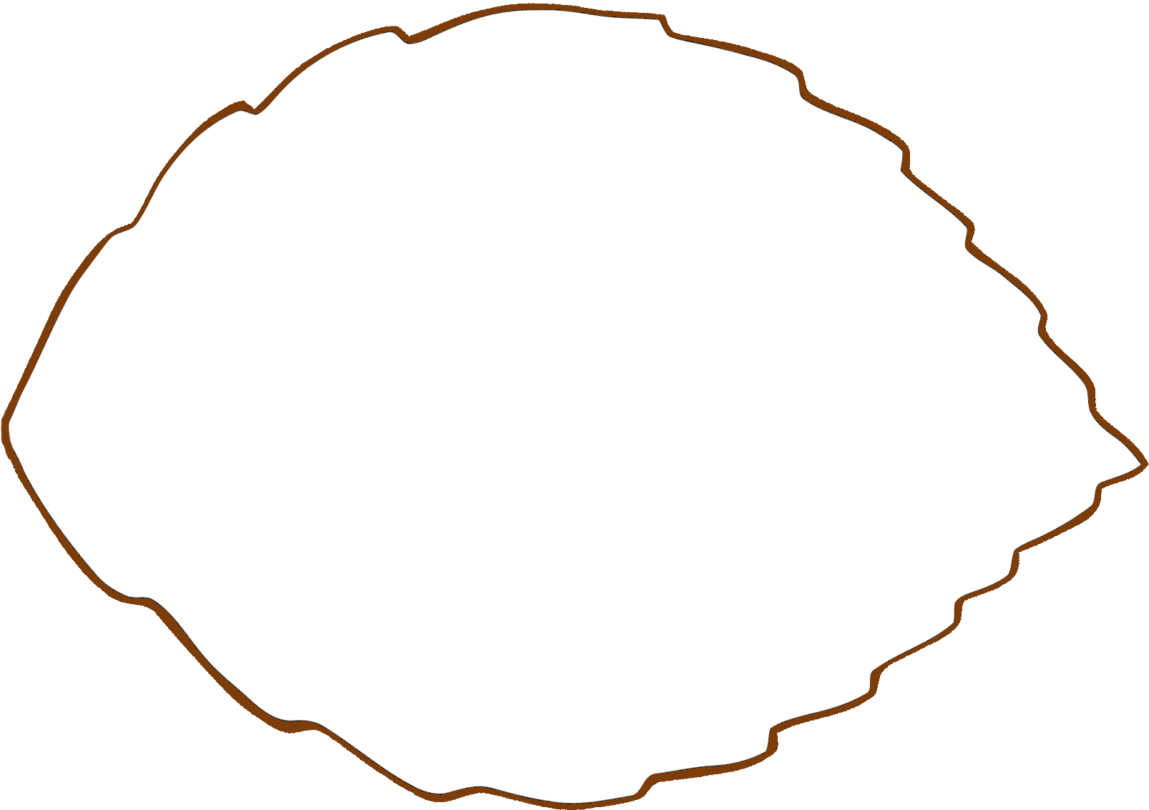

© 2021 Little Owls Resources

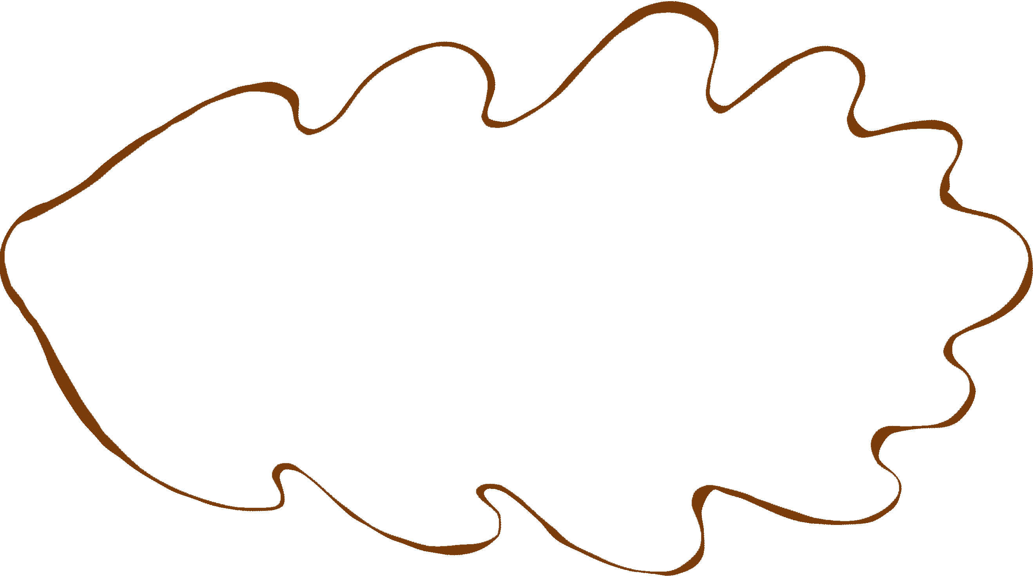

© 2021 Little Owls Resources

© 2021 Little Owls Resources



© 2021 Little Owls Resources



© 2021 Little Owls Resources