**Autumn Item Pictures**

© 2021 Little Owls Resources

These cards/mats are intended to inspire children to use natural, autumnal items to create pictures.

It is not intended for these representations to be copied exactly; any combination of natural resources will do!

v

**Can you use autumn items to make…**

© 2021 Little Owls Resources

v

a hedgehog?

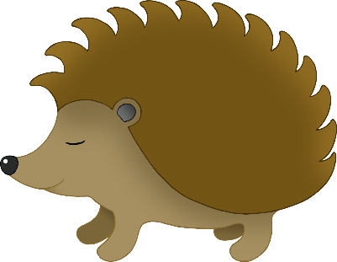

v

**Can you use autumn items to make…**

© 2021 Little Owls Resources

v

a fox?

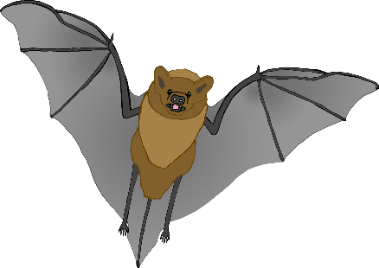

v

**Can you use autumn items to make…**

© 2021 Little Owls Resources

v

a bat?

v

**Can you use autumn items to make…**

© 2021 Little Owls Resources

v

a cat?

v

**Can you use autumn items to make…**

© 2021 Little Owls Resources

v

a squirrel?

v

**Can you use autumn items to make…**

© 2021 Little Owls Resources

v

a hand shape?

v

**Can you use autumn items to make…**

© 2021 Little Owls Resources

v

a foot shape?

