**Autumn Float and Sink**

Tick Sheet Pack

These tick sheets can be used as part of an investigation into the floating and sinking of Autumn items.

The first sheet has suggested items included. The subsequent sheets are blank for the children to write or draw the item they are testing and then record the result.

© 2021 Little Owls Resources

Float or Sink

© 2021 Little Owls Resources

Name:

Sink

Float

Tick Sheet

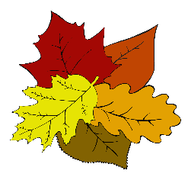

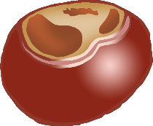

Conker

Acorn

Stone

Sycamore Seed

Leaf

Pinecone

Float or Sink

© 2021 Little Owls Resources

Name:

Sink

Float

Tick Sheet



**Float or Sink**

© 2021 Little Owls Resources

**Name:**

**Sink**

**Float**

**Tick Sheet**