**Autumn Animals**

**Fact Cards** - **(A5)**

These fact cards can be used as part of a display or as a stimulus for discussion, writing and drawing.

© 2022 Little Owls Resources

Squirrel

Fox

Body – 30 cm

Tail – 25 cm

Acorns, bulbs, nuts, and roots.

3 years

A squirrel’s home is called a ‘drey’.

Length:

Average Lifespan:

Food:

Fact:

70cm

Rabbits, frogs, rodents, birds, worms.

3 years

Length:

Average Lifespan:

Food:

Fact:

A fox’s home is called an ‘earth’.

© 2022 Little Owls Resources

© 2022 Little Owls Resources

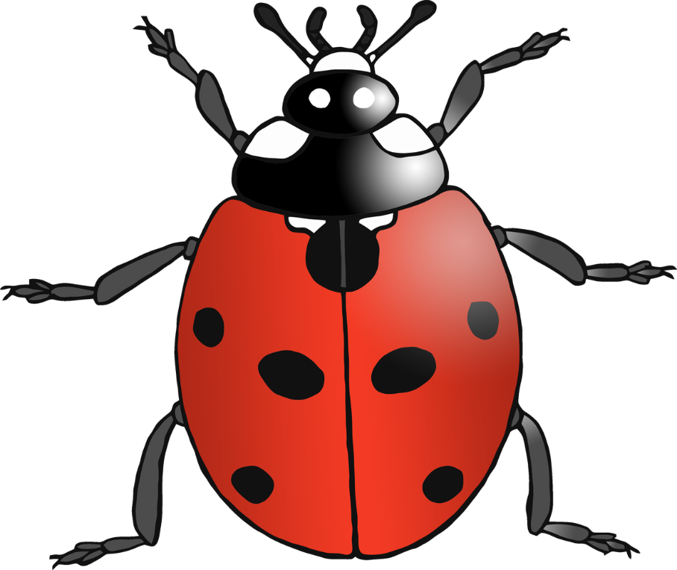

Earthworms, frogs, birds, eggs, insects, berries.

One ladybird can eat up to 5,000 insects in its lifetime!

Aphids and other small insects.

Ladybird

UK’s largest land carnivore.

14 years

90cm

1 cm

1 year

Length:

Average Lifespan:

Food:

Fact:

Length:

Average Lifespan:

Food:

Fact:

© 2022 Little Owls Resources

© 2022 Little Owls Resources

Badger

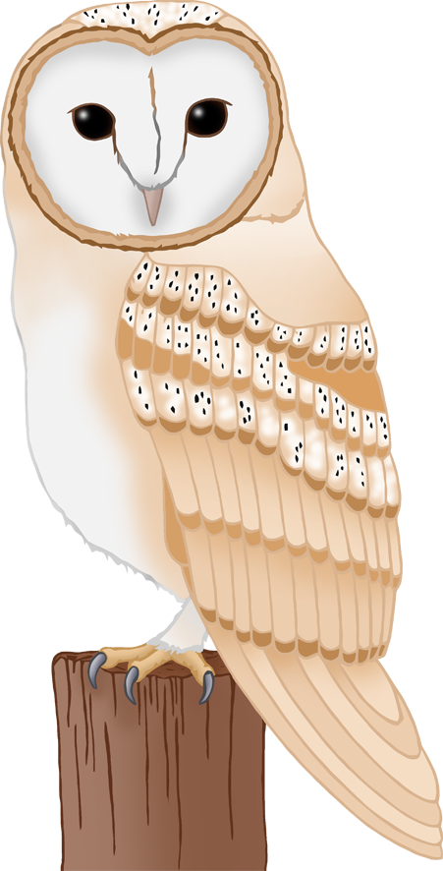

Owl ears are at uneven heights on the side of their heads

Mice, voles, shrews.

Up to 140cm at the shoulder.

35 cm

4 years

UK’s largest land mammal.

16 years

Grass, leaves, shoots.

Size:

Average Lifespan:

Food:

Fact:

Length:

Average Lifespan:

Food:

Fact:

© 2022 Little Owls Resources

© 2022 Little Owls Resources

Owl

Deer

Dormice live in trees but hibernate at ground level.

Flowers, pollen, fruits, insects and nuts.

Dormouse

Nocturnal. They hunt at night.

5 years

Moths, earwigs, flies, beetles.

8 cm

5 years

9-16 cm

Long-Eared Bat

© 2022 Little Owls Resources

© 2022 Little Owls Resources

Length:

Average Lifespan:

Food:

Fact:

Length:

Average Lifespan:

Food:

Fact:

They bury acorns in autumn for later use.

Insects, earthworms, mice, eggs and young birds, seeds, grain and fruit.

Jay

5000-7000 spines on their backs.

2-3 years

Worms, beetles, slugs, caterpillars, earwigs.

Up to 35cm

4 years

34 cm

Length:

Average Lifespan:

Food:

Fact:

Length:

Average Lifespan:

Food:

Fact:

© 2022 Little Owls Resources

© 2022 Little Owls Resources

Hedgehog