**Autumn Animals**

**Fact Cards** - **(A4)**

These fact cards can be used as part of a display or as a stimulus for discussion, writing and drawing.

© 2022 Little Owls Resources

© 2022 Little Owls Resources

Fox

**Length:**

**Average Lifespan:**

**Food:**

**Fact:**

70cm

Rabbits, frogs, rodents, birds, worms.

3 years

A fox’s home is called an ‘earth’.

© 2022 Little Owls Resources

Squirrel

Body – 30 cm

Tail – 25 cm

Acorns, bulbs, nuts, and roots.

3 years

A squirrel’s home is called a ‘drey’.

**Length:**

**Average Lifespan:**

**Food:**

**Fact:**

© 2022 Little Owls Resources

Ladybird

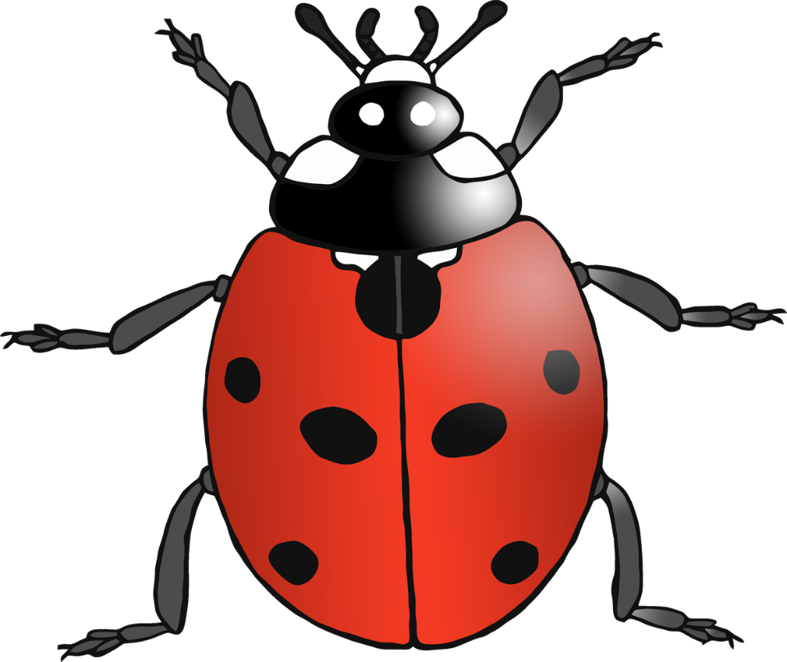

**Length:**

**Average Lifespan:**

Food:

Fact:

1 cm

Aphids and other small insects.

1 year

One ladybird can eat up to 5,000 insects in its lifetime!

**Length:**

**Average Lifespan:**

**Food:**

**Fact:**

90cm

Earthworms, frogs, birds, eggs, insects, berries.

14 years

UK’s largest land carnivore.

© 2022 Little Owls Resources

Badger

© 2022 Little Owls Resources

Deer

**Size:**

**Average Lifespan:**

**Food:**

**Fact:**

Up to 140cm at the shoulder.

Grass, leaves, shoots.

16 years

UK’s largest land mammal.

© 2022 Little Owls Resources

Owl

**Length:**

**Average Lifespan:**

**Food:**

**Fact:**

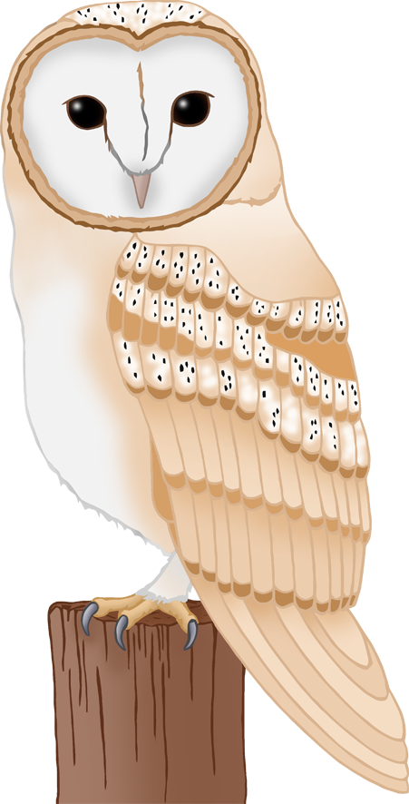

35 cm

Mice, voles, shrews.

4 years

Owl ears are at uneven heights on the side of their heads

© 2022 Little Owls Resources

Dormouse

**Length:**

**Average Lifespan:**

**Food:**

**Fact:**

9- 16cm

Flowers, pollen, fruits, insects and nuts.

5 years

Dormice live in trees but hibernate at ground level.

© 2022 Little Owls Resources

Long-Eared Bat

8 cm

Moths, earwigs, flies, beetles.

5 years

Nocturnal. They hunt at night.

**Length:**

**Average Lifespan:**

**Food:**

**Fact:**

**Length:**

**Average Lifespan:**

**Food:**

**Fact:**

34 cm

Insects (especially caterpillars and beetles), earthworms, mice, eggs and young birds, seeds, grain and fruit.

4 years

They bury acorns in autumn for later use.

© 2022 Little Owls Resources

Eurasian Jay

Up to 35cm

Worms, beetles, slugs, caterpillars, earwigs.

2-3 years

5000-7000 spines on their backs.

**Length:**

**Average Lifespan:**

**Food:**

**Fact:**

© 2022 Little Owls Resources

Hedgehog