**Autumn Activity**

**Challenge!**

1

Crawl along the floor like a hedgehog.

**Snuffle! Snuffle!**

2

Float through the air like a falling leaf.

© 2022 Little Owls Resources

**Autumn Activity**

**Challenge!**

© 2022 Little Owls Resources

3

Search around to find a nut like a squirrel.

**Jump! Stop! Jump! Stop!**

4

Twirl and spin like a falling sycamore seed.

**Twirl! Spin!**

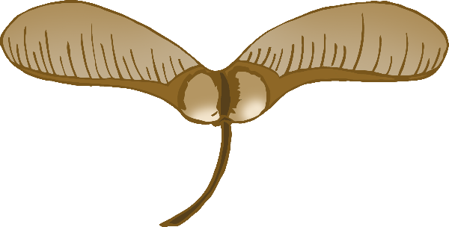

**Autumn Activity**

**Challenge!**

**Autumn Activity**

**Challenge!**

© 2022 Little Owls Resources

© 2022 Little Owls Resources

5

Creep slowly and carefully like a fox.

**Creep… Freeze! Look around!**

6

Flap and fly like a bat in the dark!

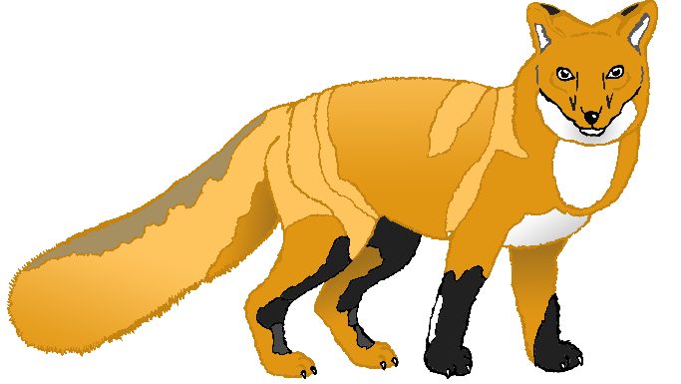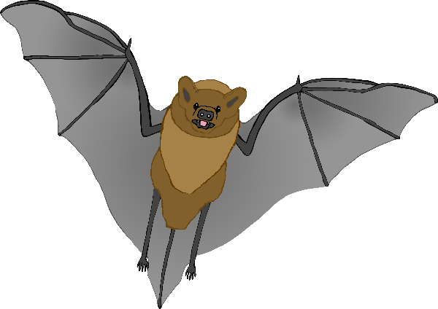

**Autumn Activity**

**Challenge!**

**Autumn Activity**

**Challenge!**

© 2022 Little Owls Resources

© 2022 Little Owls Resources

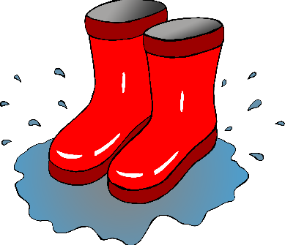

**Autumn Activity**

**Challenge!**

© 2022 Little Owls Resources

© 2022 Little Owls Resources

**Autumn Activity**

**Challenge!**

7

Jump in puddles!

**Splish! Splash!**

8

Rake the leaves into one big pile.

**Rake! Rake!**