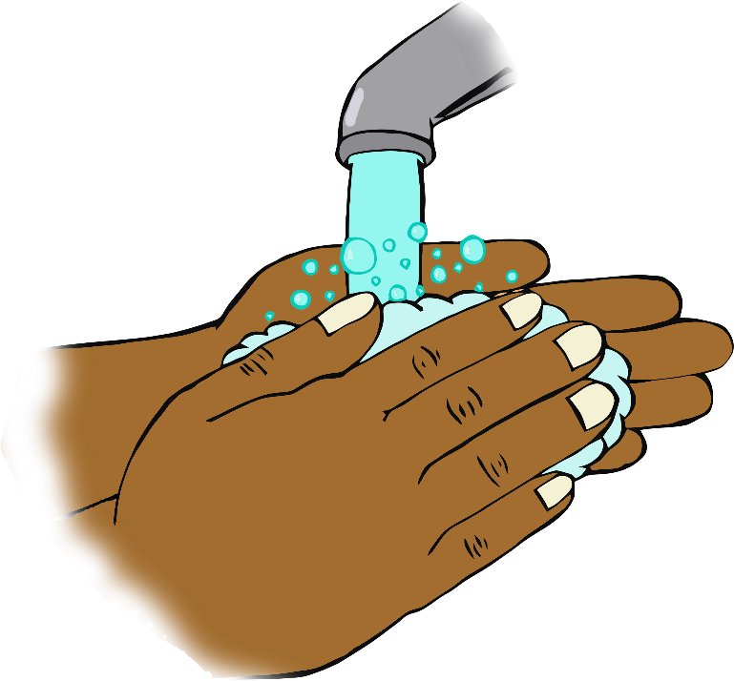

“Hello!”

**When you arrive…**

**Wash your hands!**