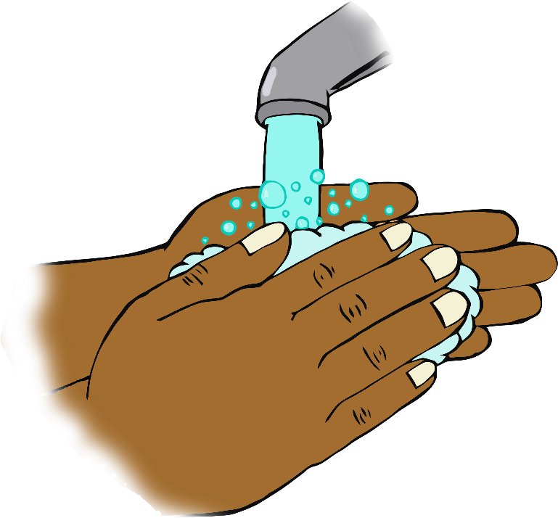

© 2020 Little Owls Resources

**When you arrive…**

“Hello!”

**Wash your hands!**