**Animals of**

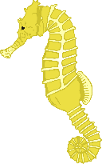

© 2020 Little Owls Resources

**the World**

**Omnivores**

**Herbivores**

**Carnivores**

**Wild**

**Tame**

**Domestic**

**Desert**

**Land**

**Sea**

**Snow**

**Forest**

**Farm**

**Pond**

**River**

**Jungle**

**Mountains**

**Hot**

**Cold**