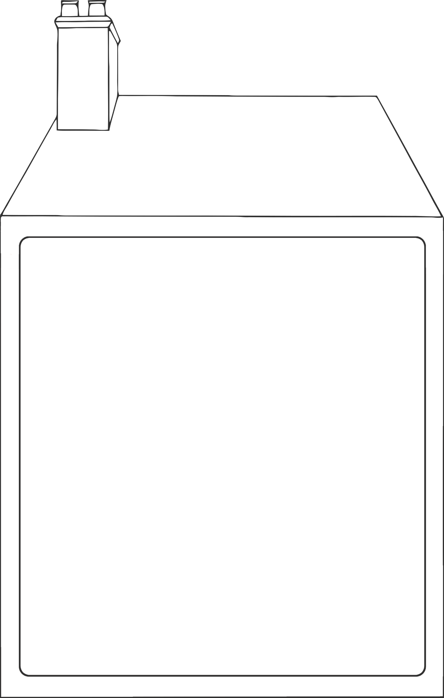

© 2023 Little Owls Resources

How many animals can you fit into the house?

© 2023 Little Owls Resources

How many animals can you fit into the house?