Animals in Winter - UK

Some animals can conserve their energy during the winter. They go to sleep for a long time when it is cold and food is more difficult to find.

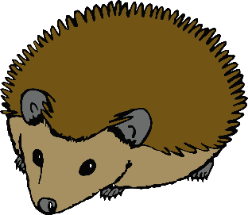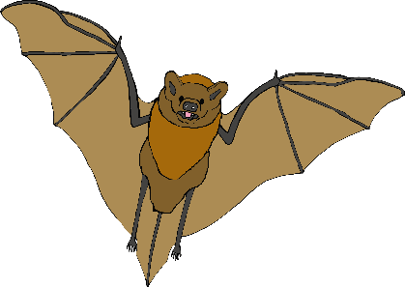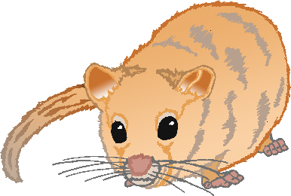

In insects this is called **DIAPAUSE**.

(A slow state that insects enter when it is too cold or there is little food)

Ladybird

Butterfly

Bumblebee

Frog

In cold-blooded animals this is called **BRUMATION**.

(A long sleep, but they may get up and move on warmer days)

Slow-worm

In warm-blooded animals this is called **HIBERNATION**.

(A long, deep, sleep)

Hedgehog

Bat

Dormouse