**What made that footprint in the snow?**

Fox

Dog

Cat

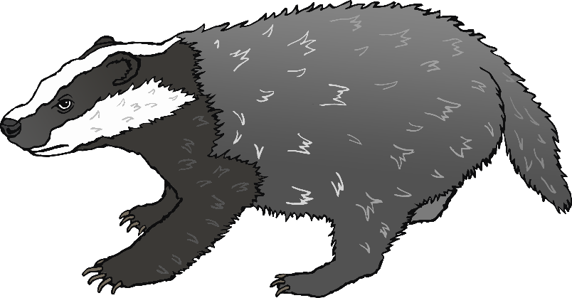

Badger

Squirrel

Deer