k

a

y

f

o

x

c

o**w**

b

ee

d

ee

r

g

oa

t

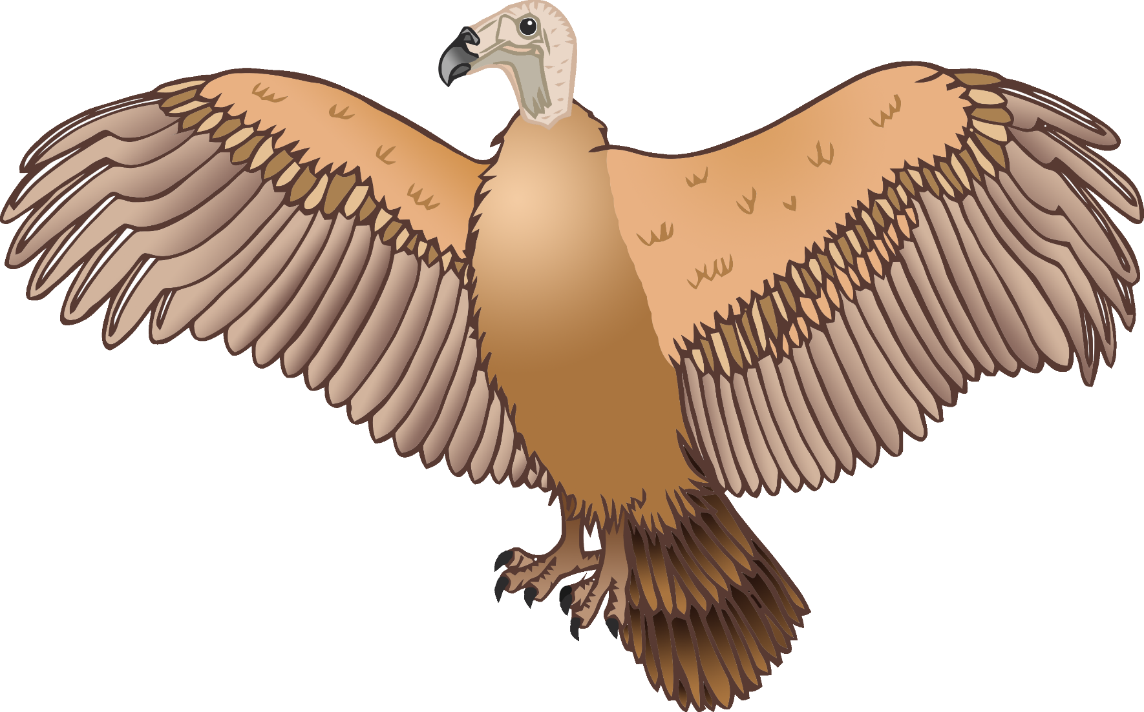

v

u

l

t

ure

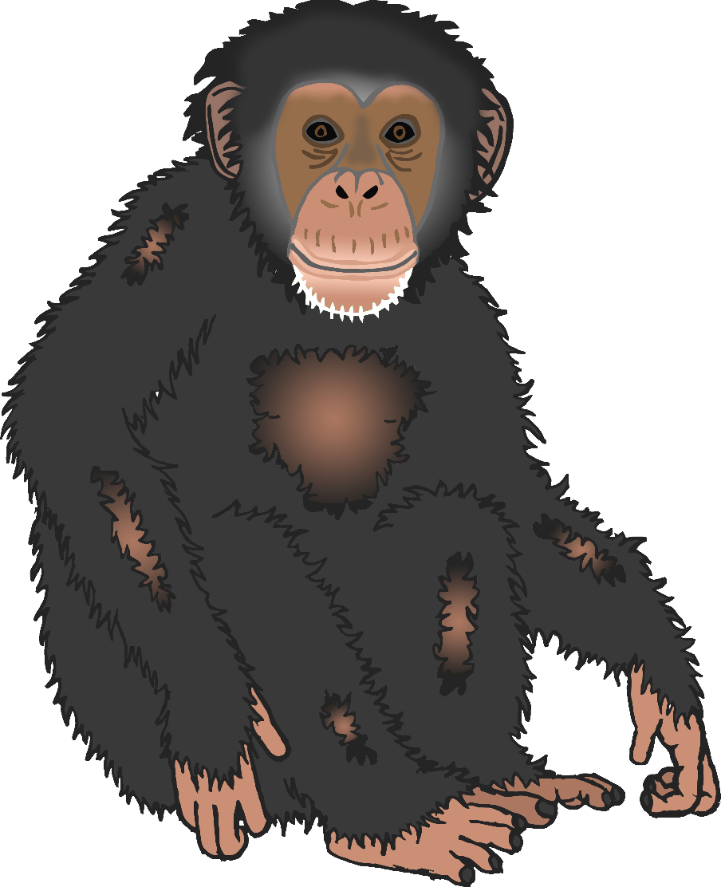

p

ch

i

m

l

qu

ai

p

sh

ee

n

s

l

ai

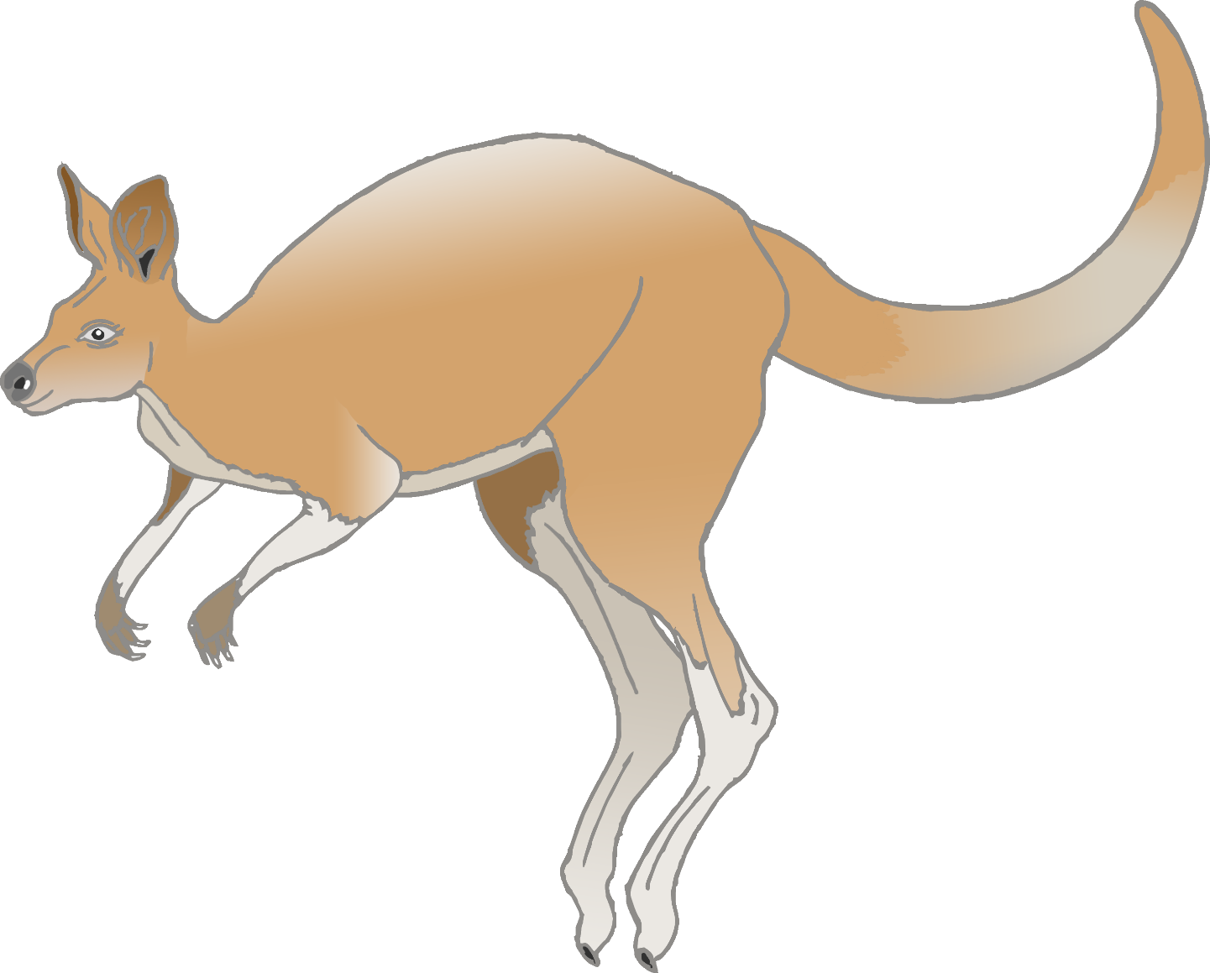

k

oo

r

a

n

g

a