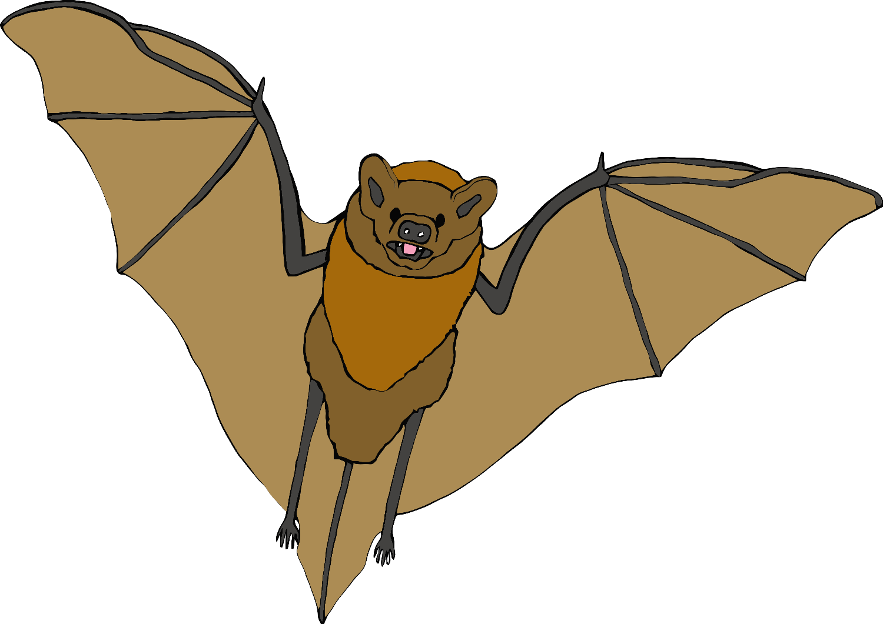

t

a

b

t

n

a

g

p

i

g

o

d

t

a

c

h

e

n

g

o

r

f

ck

u

d