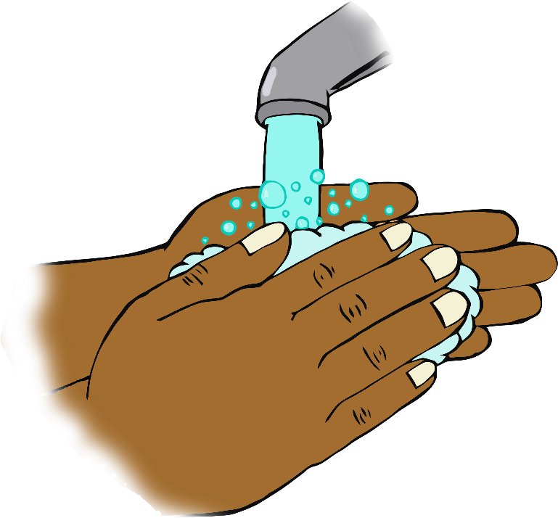

**After handling animals…**

**Wash your hands!**