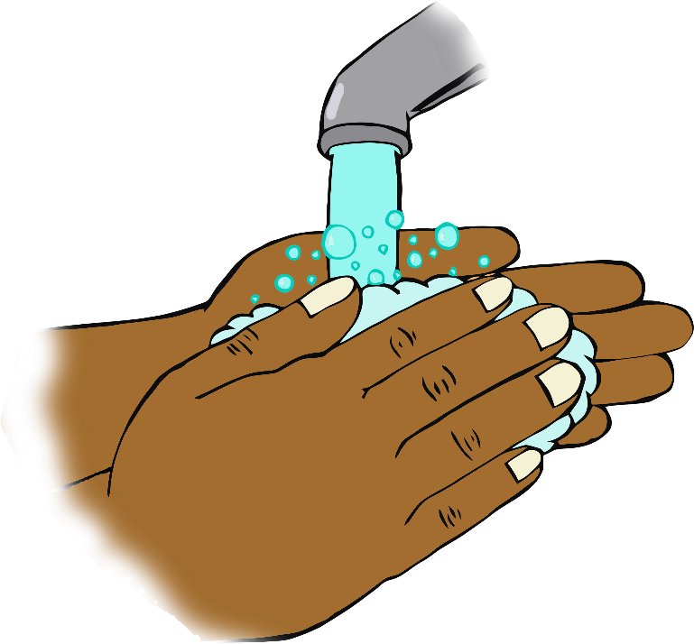

**After handling animals…**

© 2020 Little Owls Resources

**Wash your hands!**