4 legs

© 2020 Little Owls Resources

© 2020 Little Owls Resources

2 legs

0 legs

© 2020 Little Owls Resources

© 2020 Little Owls Resources

Eats meat

Eats plants

Eats both

© 2020 Little Owls Resources

© 2020 Little Owls Resources

© 2020 Little Owls Resources

© 2020 Little Owls Resources

**✓**

Can’t fly

Can fly

© 2020 Little Owls Resources

© 2020 Little Owls Resources

**✓**

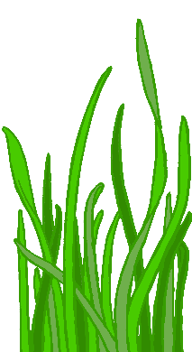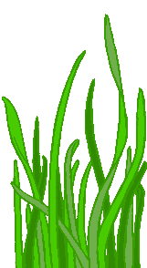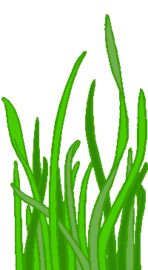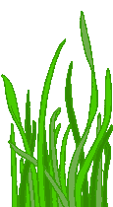

Can walk

Can’t walk

Lives on land

© 2020 Little Owls Resources

© 2020 Little Owls Resources

Lives in the water

Lives on land and in the water

© 2020 Little Owls Resources

© 2020 Little Owls Resources

Has fur

Has no

fur or feathers

Has feathers

© 2020 Little Owls Resources

© 2020 Little Owls Resources

© 2020 Little Owls Resources

© 2020 Little Owls Resources

© 2020 Little Owls Resources

© 2020 Little Owls Resources

© 2020 Little Owls Resources

© 2020 Little Owls Resources

© 2020 Little Owls Resources

© 2020 Little Owls Resources

© 2020 Little Owls Resources

© 2020 Little Owls Resources

© 2020 Little Owls Resources

© 2020 Little Owls Resources

© 2020 Little Owls Resources

© 2020 Little Owls Resources

© 2020 Little Owls Resources