squirrel

tiger

s

a

t

ant

n

i

p

narwhal

iguana

pig

g

m

d

dog

goose

mouse

c

o

k

donkey

cat

octopus

ck

e

u

umbrella bird

elephant

duck

r

h

b

hen

rabbit

butterfly

frog

lion

l

f

ff

giraffe

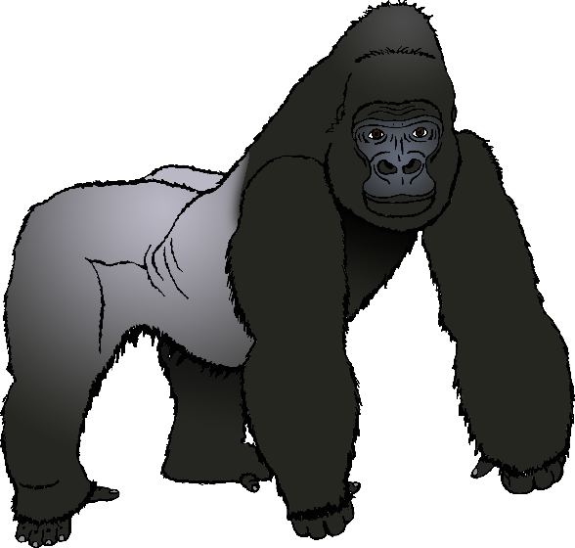

ss

ll

gorilla

possum