© 2020 Little Owls Resources

Animal Number Multimats

These mats can be laminated and used as:

* Playdough mats
* Number writing practice sheets
* Loose part activity sheets
* A large number display

We hope it helps!

**1**

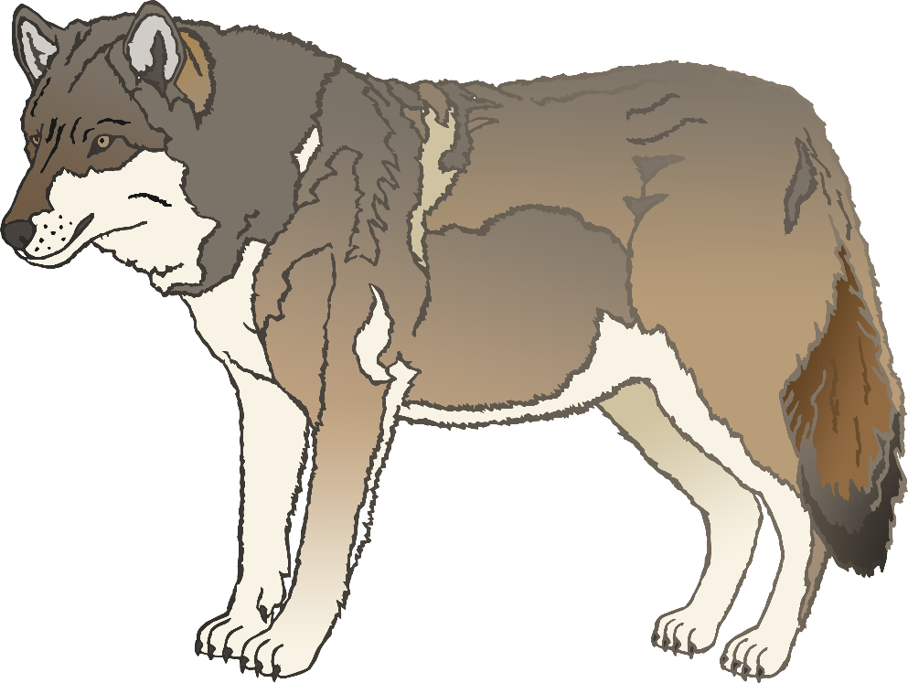

**2**

**3**

**4**

**5**

**6**

**7**

**8**

**9**

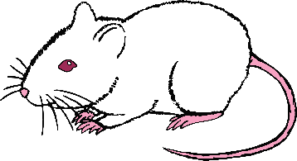

**10**



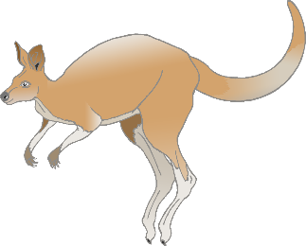

**11**



**12**

**13**

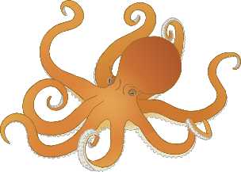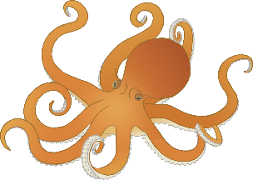

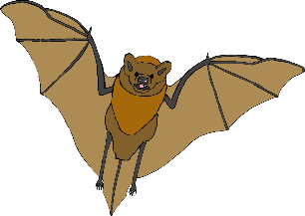

**14**



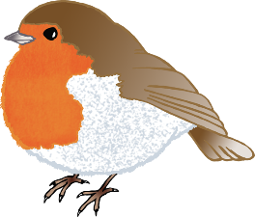

**15**



**16**

**17**

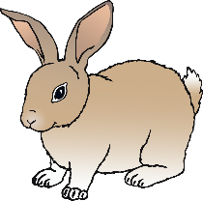

**18**



**19**

**20**

