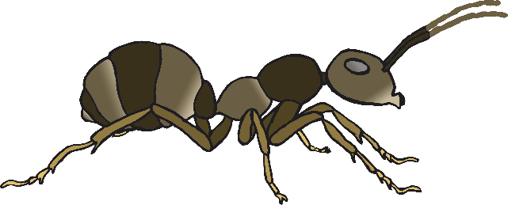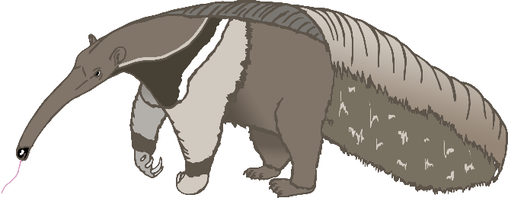

a

a

b

b

c

c

d

d

f

f

g

g

h

h

l

l

m

m

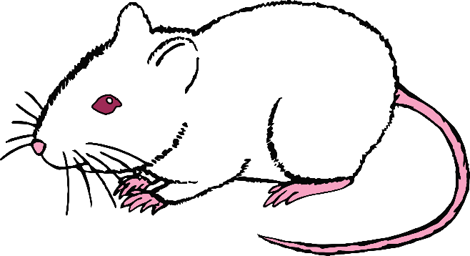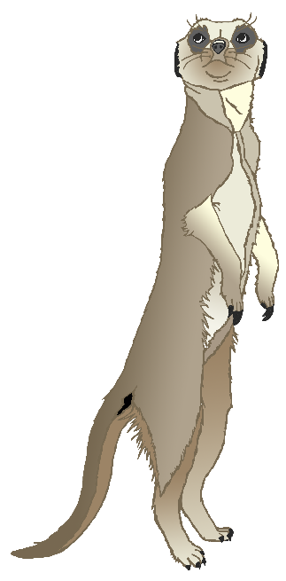

p

p

r

r

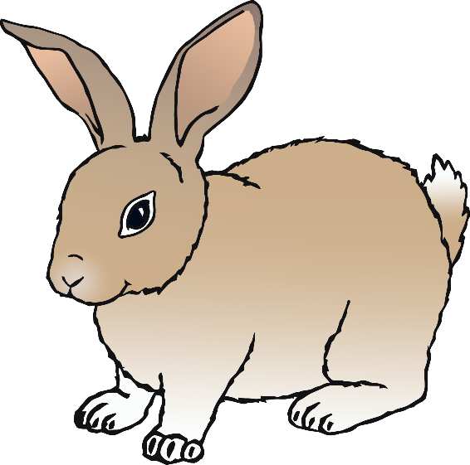

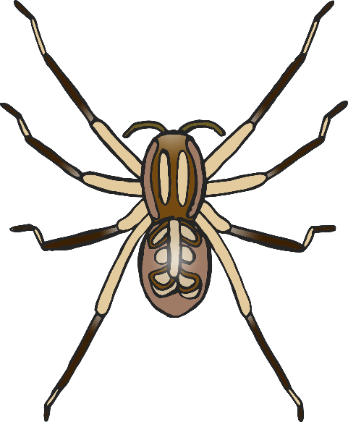

s

s