**Animal Height Chart**

© 2020 Little Owls Resources

© 2020 Little Owls Resources

50cm

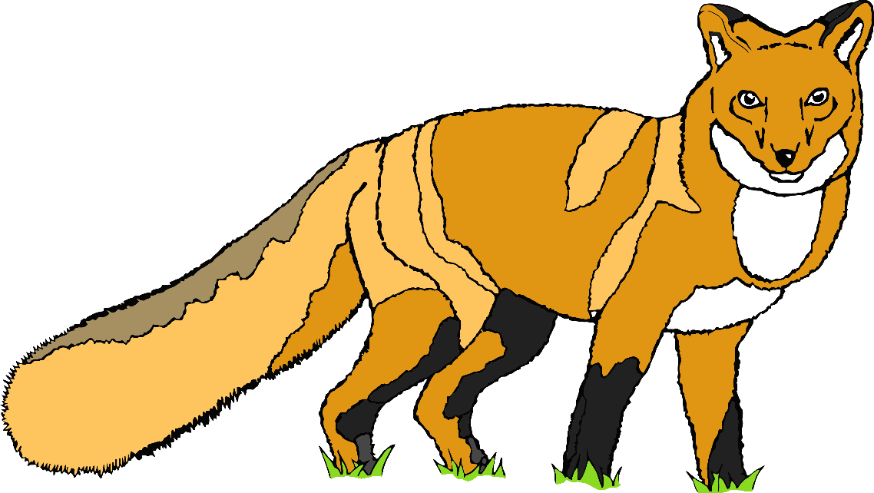

**Fox**

© 2020 Little Owls Resources

80cm

**Wolf**

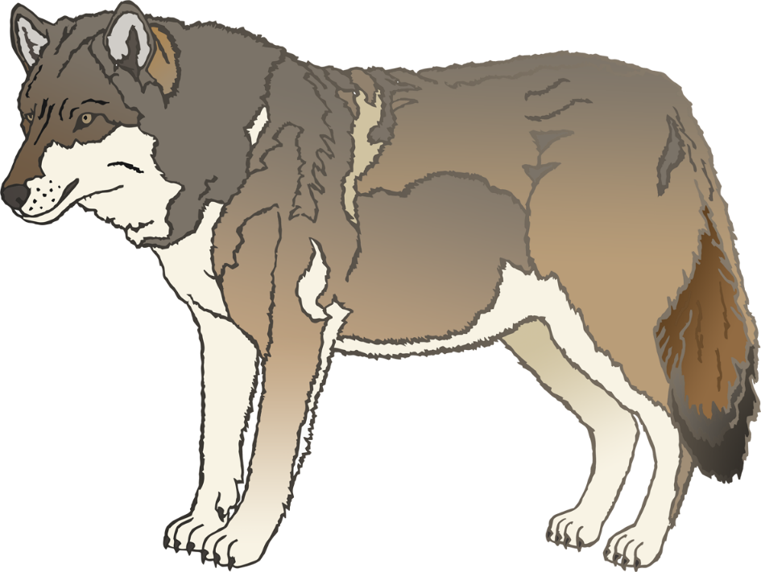

© 2020 Little Owls Resources

85cm

**Pig**

© 2020 Little Owls Resources

100cm

**Flamingo**

© 2020 Little Owls Resources

105cm

**Tiger**

© 2020 Little Owls Resources

115cm

**Vulture**

© 2020 Little Owls Resources

120cm

**Lion**

© 2020 Little Owls Resources

150cm

**Cow**

© 2020 Little Owls Resources

170cm

**Rhino**