**Animal Descriptions**

Children to answer with animal noises!

© 2020 Little Owls Resources

Fold along the line

**?**

© 2020 Little Owls Resources

This animal has four legs.

This animal eats grass.

We get milk from this animal.

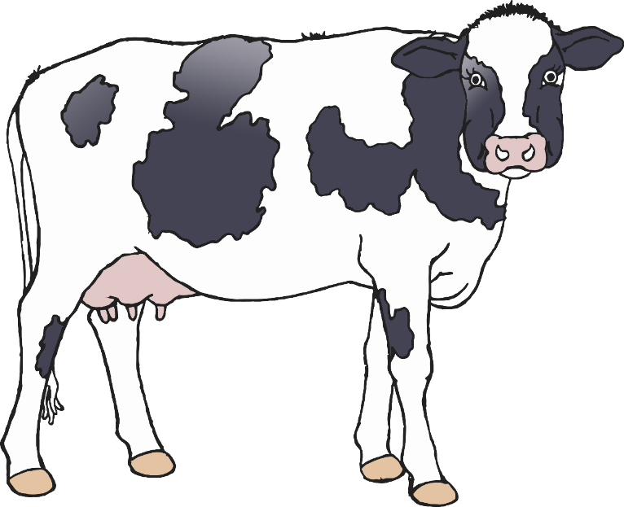

**?**

© 2020 Little Owls Resources

This animal is a pet.

This animal wags its tail.

This animal likes bones.

**?**

© 2020 Little Owls Resources

This animal has four legs.

This animal likes to catch mice.

This animal has whiskers.

**?**

© 2020 Little Owls Resources

This animal has four legs.

This animal has a curly tail.

This animal likes sitting in mud.

**?**

© 2020 Little Owls Resources

This animal has two wings.

This animal has two legs.

We get eggs from this animal.

**?**

© 2020 Little Owls Resources

This animal has two legs.

This animal can fly.

This animal likes to float on water.

**?**

© 2020 Little Owls Resources

This animal has four legs.

This animal eats grass.

We get wool from this animal.

**?**

© 2020 Little Owls Resources

This animal has four legs.

This animal eats meat with its sharp teeth.

This animal is a big type of cat.

**?**

© 2020 Little Owls Resources

This animal has no legs.

This animal flicks its tongue in and out.

This animal slides along the ground.

**?**

© 2020 Little Owls Resources

This animal is small.

This animal squeezes through small holes.

This animal has a thin tail.

