Animal dance cards - Adverbs

After being folded and laminated these cards can be used to encourage expressive movement with or without music.

The large image side is to be held facing the child(ren) with the other side being read by an adult.

fold along centre line

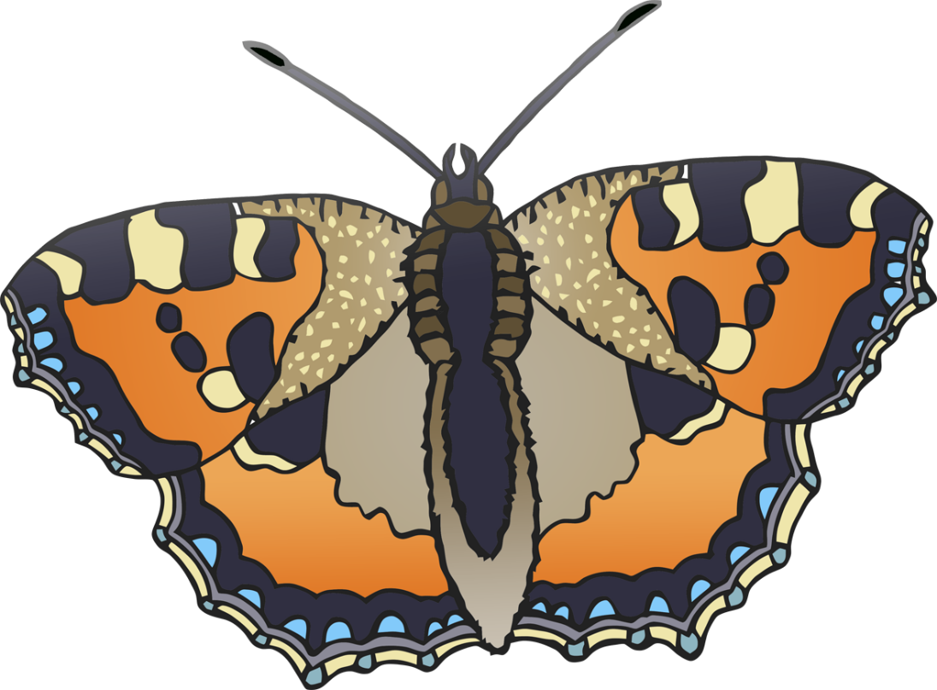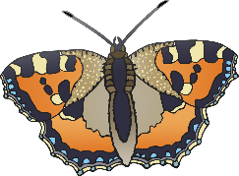

like a

butterfly

**lightly**

**lightly**

Move

© 2021 Little Owls Resources

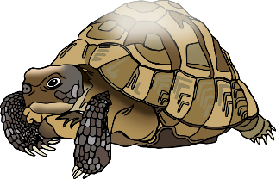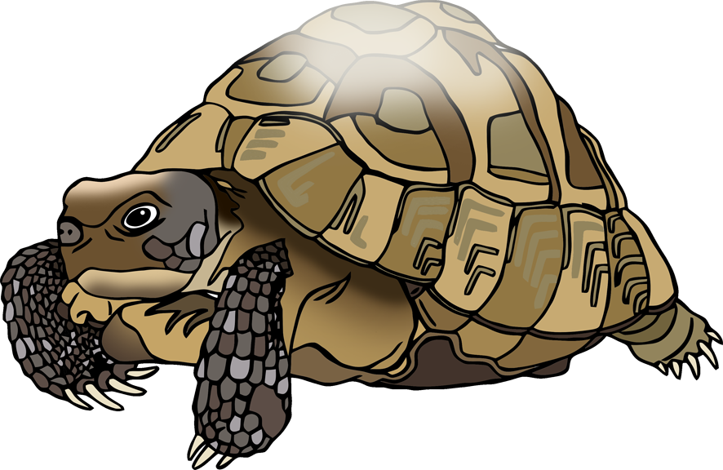

**steadily**

like a

**steadily**

tortoise

Move

© 2021 Little Owls Resources

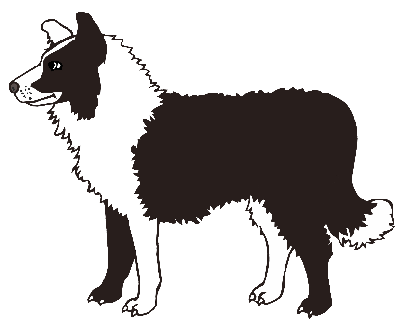

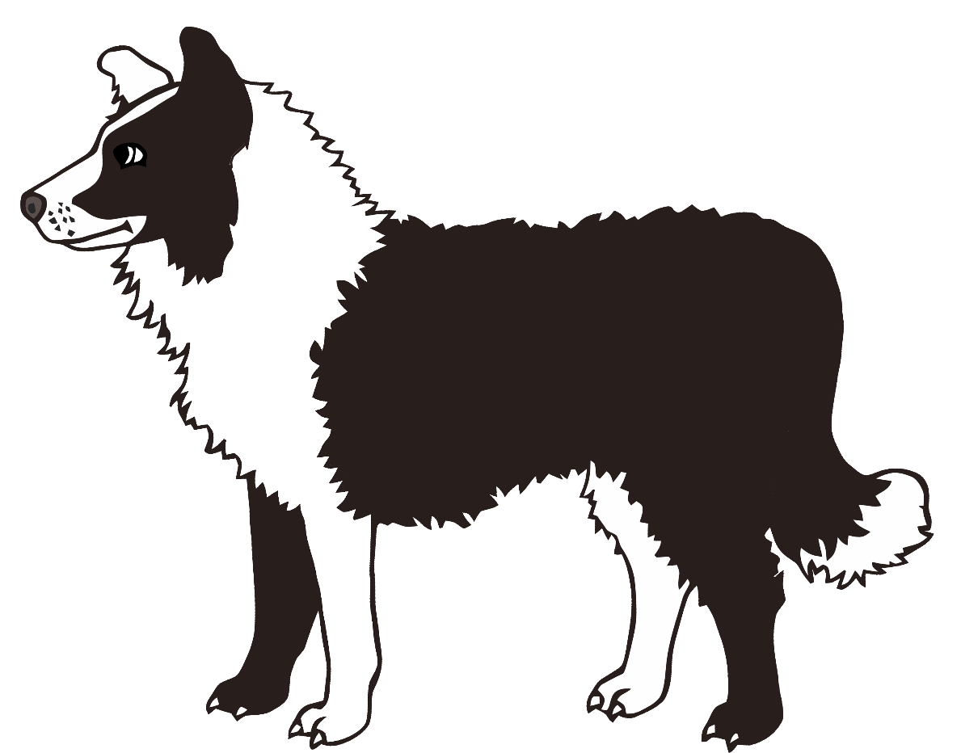

Move

dog

like a

**happily**

**happily**

© 2021 Little Owls Resources

**suddenly**

**suddenly**

like a

tiger

Move

© 2021 Little Owls Resources

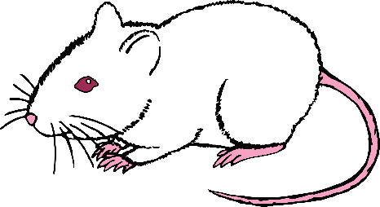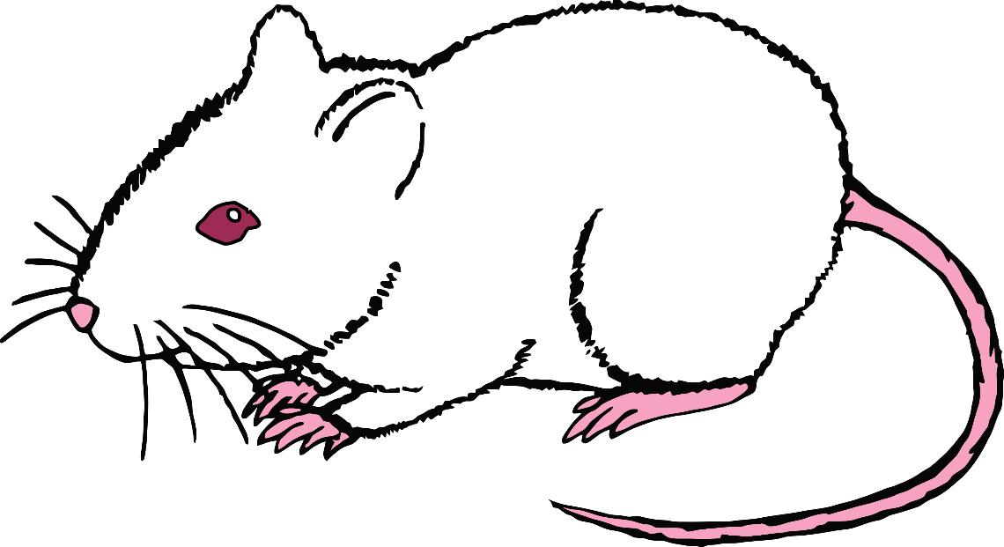

**quietly**

**quietly**

like a

mouse

Move

© 2021 Little Owls Resources

**delicately**

**delicately**

like a

cat

Move

© 2021 Little Owls Resources

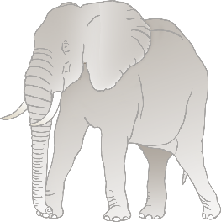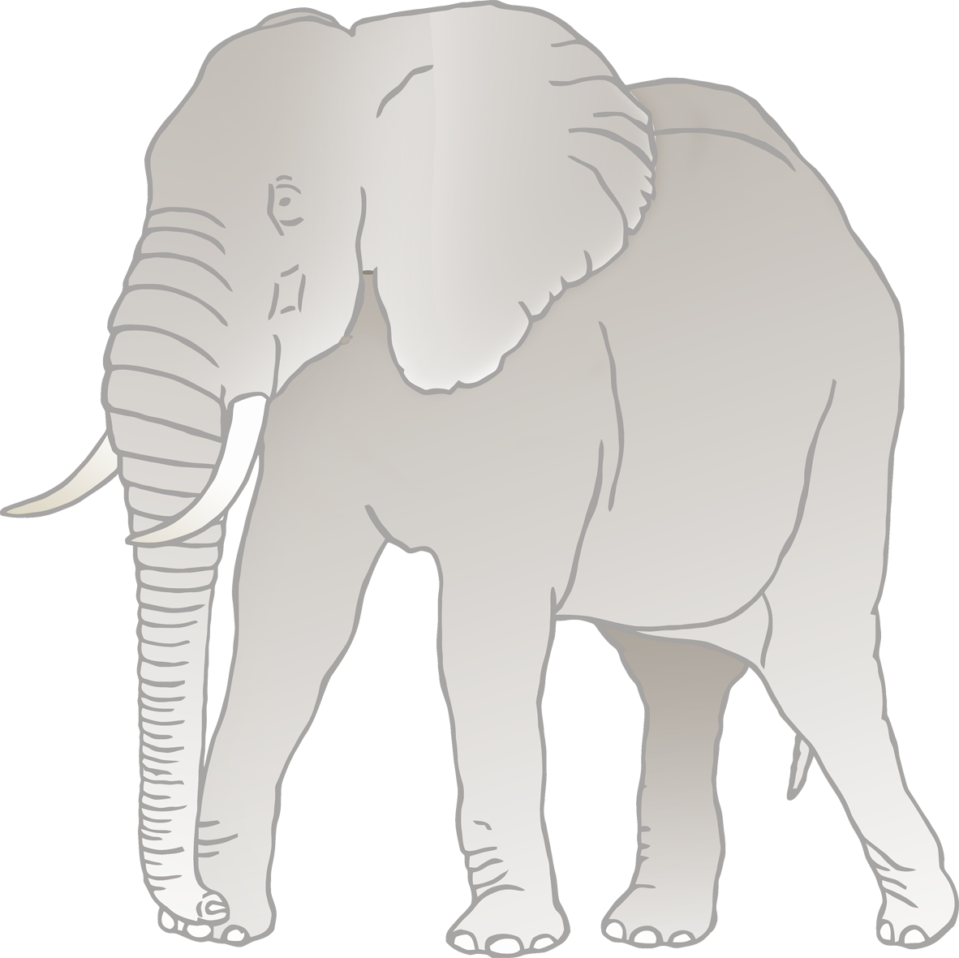

**heavily**

**heavily**

like an

elephant

Move

© 2021 Little Owls Resources

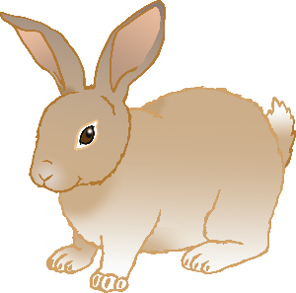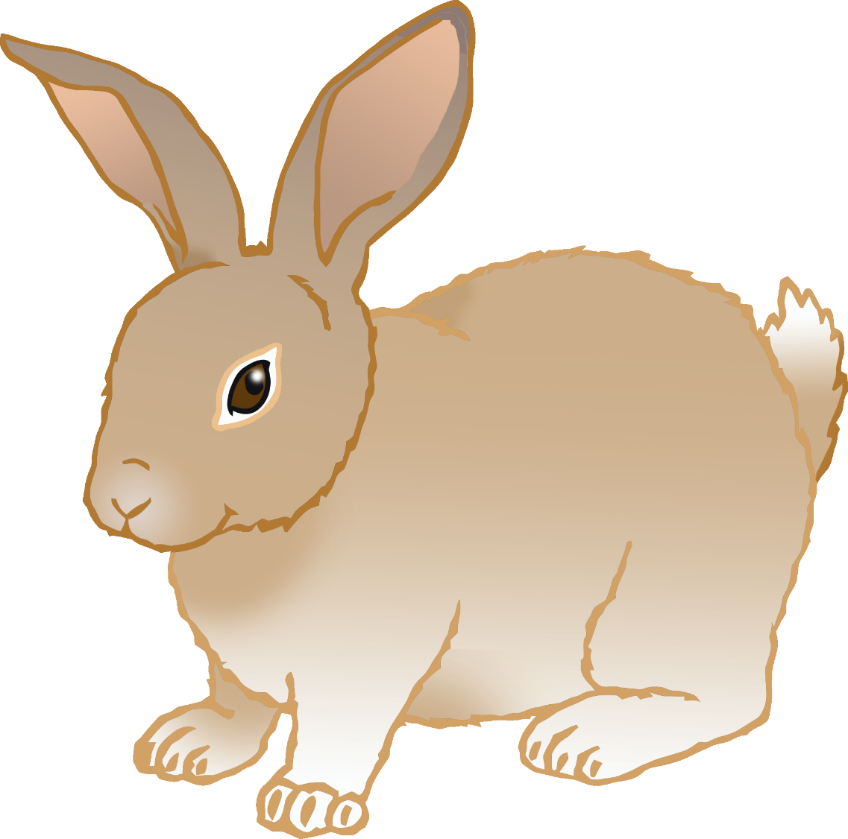

**quickly**

Move

rabbit

like a

**quickly**

© 2021 Little Owls Resources

**slowly**

**slowly**

like a

snail

Move

© 2021 Little Owls Resources

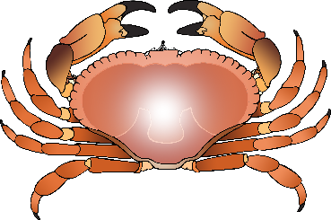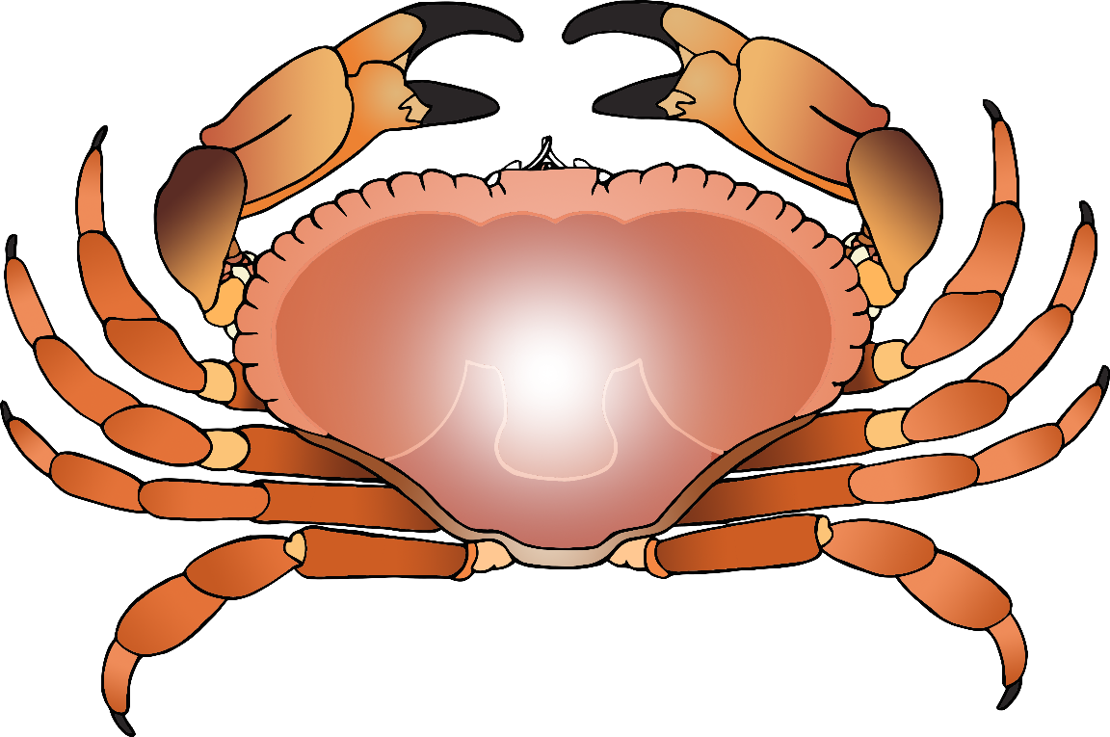

**jerkily**

**jerkily**

like a

crab

Move

© 2021 Little Owls Resources

**awkwardly**

Move

penguin

like a

**awkwardly**

© 2021 Little Owls Resources

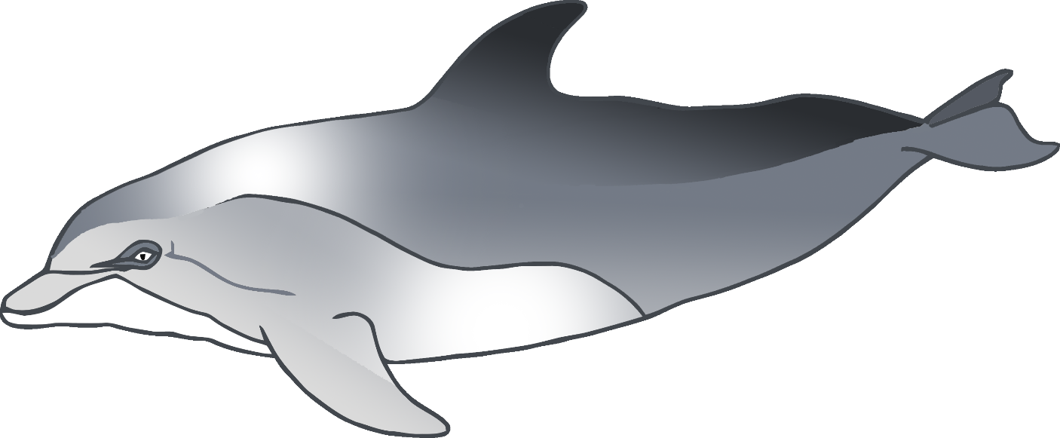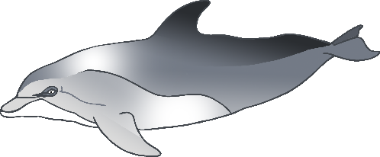

**swiftly**

**swiftly**

like a

dolphin

Move

© 2021 Little Owls Resources

Move

fish

like a

**gracefully**

**gracefully**

© 2021 Little Owls Resources

**carefully**

**carefully**

like a

squirrel

Move

© 2021 Little Owls Resources

**smoothly**

Move

snake

like a

**smoothly**

© 2021 Little Owls Resources