© 2019 Little Owls Resources



www.littleowls-premium.com *EDITABLE Resource*

English/Welsh

www.littleowls-premium.com © 2019 Little Owls Resources

www.littleowls-premium.com © 2019 Little Owls Resources

www.littleowls-premium.com © 2019 Little Owls Resources

English/Welsh

elephant

eliffant

(el-ee-fant)

English/Welsh

lion

llew

(cch-loo)

English/Welsh

tiger

teigr

(t-eye-g)

**Animal Cards**

✱ The sound ‘cch’ has no common English equivalent. It is made in the back of the throat as in the Scots word lo**ch**.

English/Welsh

giraffe

jiraff

(jee-raff)

English/Welsh

penguin

pengwin

(pen-gwin)

English/Welsh

chimpanzee

tsimpansî

(t-sim-pan-see)

English/Welsh

flamingo

fflamingo

(flam-in-go)

English/Welsh

komodo dragon

draig komodo

(drr-eye-g ko-moh-doh)

English/Welsh

sea lion

llew môr

(cch-loo-mor)

English/Welsh

rhinoceros

rhinoseros

(ree-noss-air-ross)

English/Welsh

frog

broga

(broh-ga)

English/Welsh

wolf

blaidd

(bl-eye-th)

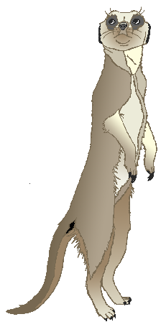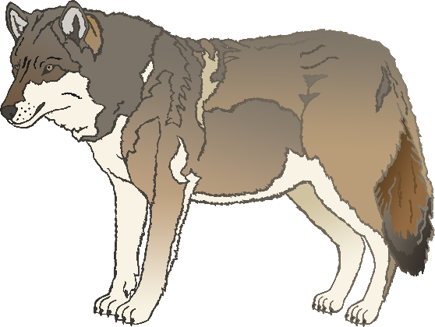

English/Welsh

cow

buwch

(boo-cch)

English/Welsh

meerkat

meerkat

(meer-kat)

English/Welsh

zebra

sebra

(seh-bra)

English/Welsh

horse

ceffyl

(keff-ill)

English/Welsh

pig

mochyn

(moh-cch-in)

English/Welsh

goat

gafr

(gav-reh)

English/Welsh

donkey

asyn

(a-ssin)

English/Welsh

dog

ci

(kee)

English/Welsh

duck

hwyaden

(h-wee-ad-en)

English/Welsh

goose

gwydd

(goy-th)

English/Welsh

sheep

dafad

(dav-ad)

English/Welsh

chicken

cyw iâr

(coo-yar)

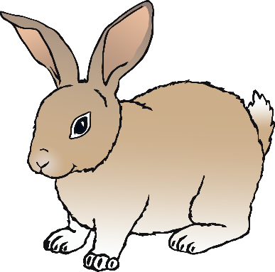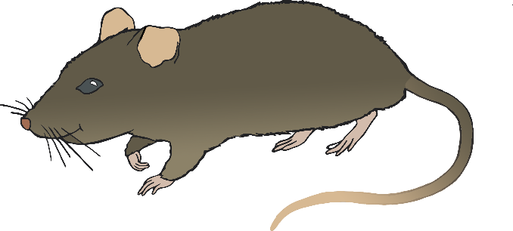

English/Welsh

bird

aderyn

(a-deh-roon)

English/Welsh

rabbit

cwningen

(cun-ing-in)

English/Welsh

rat

llygoden fawr

(cch-l-god-en f-ou)

English/Welsh

ox

ych

(ee-cch)

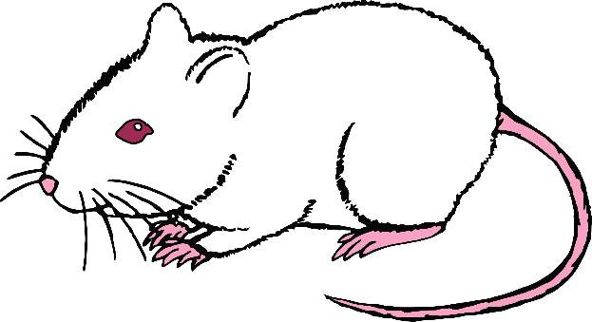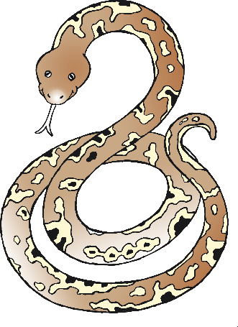

English/Welsh

cat

cath

(carth)

English/Welsh

ram

llygoden

(cch-l-god-en)

English/Welsh

snake

neidr

(n-eye-d)

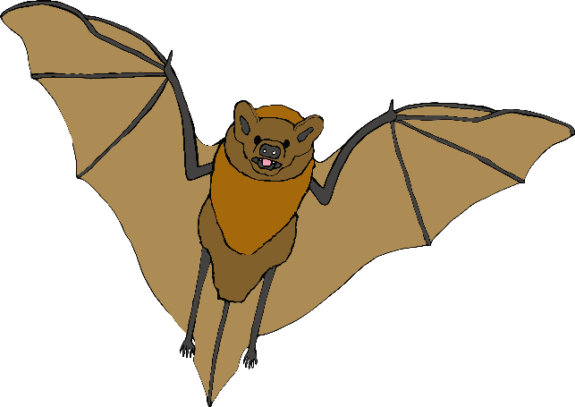

English/Welsh

bat

ystlum

(erst-lim)

English/Welsh

squirrel

wiwer

(wee-wair)

English/Welsh

fox

llwynog

(cch-loo-nog)

English/Welsh

hedgehog

draenog

(dr-eye-nog)

