© 2019 Little Owls Resources



www.littleowls-premium.com *EDITABLE Resource*

English/Urdu

www.littleowls-premium.com © 2019 Little Owls Resources

www.littleowls-premium.com © 2019 Little Owls Resources

www.littleowls-premium.com © 2019 Little Owls Resources

English/Urdu

elephant

ہاتھی

(hut-ee)

English/Urdu

lion

ببر شیر

(bubba-sh-air)

English/Urdu

tiger

شیر

(sh-air)

**Animal Cards**

English/Urdu

giraffe

زرافہ

(zeh-ruff-ah)

English/Urdu

penguin

بطریق

(butt-ah-reek)

English/Urdu

chimpanzee

چمپانزی

(chum-pun-zee)

English/Urdu

flamingo

فلیمنگو

(fil-ee-mun-goh)

English/Urdu

komodo dragon

کموڈو ڈریگن

(ko-moh-doh dray-gun)

English/Urdu

sea lion

سمندر شیر

(sum-un-deh-sh-air)

English/Urdu

rhinoceros

گینڈا

(gen-dee)

English/Urdu

frog

میڑک

(mayn-duk)

English/Urdu

wolf

بهیڑیا

(b-air-ee-ya)

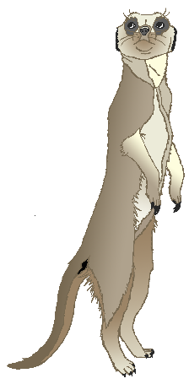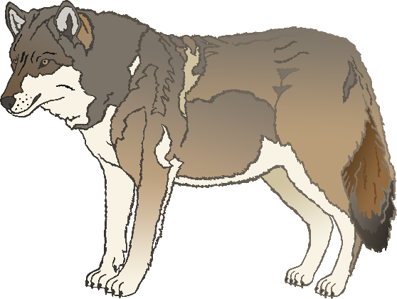

English/Urdu

cow

گائے

(g-eye)

English/Urdu

meerkat

میرکات۔

(meer-kut)

English/Urdu

zebra

زیبرا

(zeh-brah)

English/Urdu

horse

گھوڑا

(gor-uh)

English/Urdu

pig

سور

(soo-ur)

English/Urdu

goat

بکرا

(buk-ah-rah)

English/Urdu

donkey

گدھا

(gad-hah)

English/Urdu

dog

کتا

(kut-ah)

English/Urdu

duck

بطخ

(but-ukh)

English/Urdu

goose

ہنس

(hun-ss)

English/Urdu

sheep

بھیڑ

(b-air-d)

English/Urdu

chicken

مرغی

(moor-g-ee)

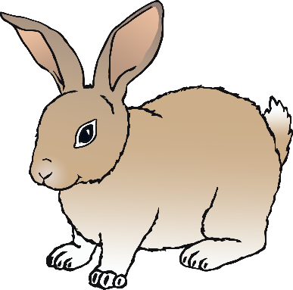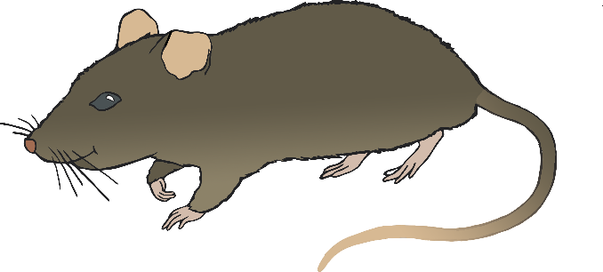

English/Urdu

bird

پرندہ

(pun-dah)

English/Urdu

rabbit

خرگوش

(kar-goh-sh)

English/Urdu

rat

چوہا

(ch-oh-hah)

English/Urdu

ox

بیل۔

(bay-l)

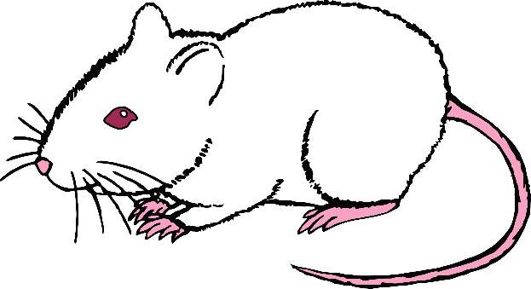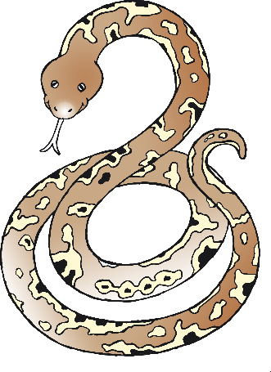

English/Urdu

cat

بلی

(bil-ee)

English/Urdu

mouse

موش

(moosh)

English/Urdu

snake

سانپ

(sarnp)

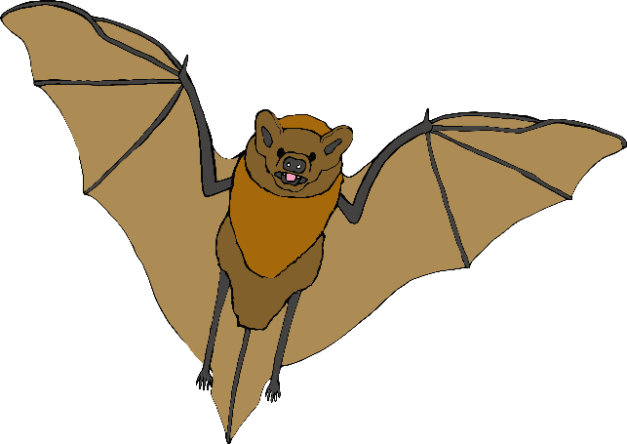

English/Urdu

bat

چمگادڑ

(cham-gar-duh)

English/Urdu

squirrel

گلہری

(goo-lar-ee)

English/Urdu

fox

لومڑی

(loom-ree)

English/Urdu

hedgehog

لومڑی

(kar-poosht)

