© 2019 Little Owls Resources



www.littleowls-premium.com *EDITABLE Resource*

English/Spanish

**Animal Cards**

www.littleowls-premium.com © 2019 Little Owls Resources

www.littleowls-premium.com © 2019 Little Owls Resources

English/Spanish

elephant

elefante

(ell-ay-fan-tay)

English/Spanish

lion

león

(lay-on)

www.littleowls-premium.com © 2019 Little Owls Resources

English/Spanish

tiger

tigre

(tee-gray)

English/Spanish

giraffe

jirafa

(jeer-raffar)

English/Spanish

penguin

pingüino

(pin-gween-oh)

English/Spanish

chimpanzee

chimpancé

(chim-pan-say)

or (chim-pan-th-ay)

English/Spanish

flamingo

flamenco

(fla-men-coh)

English/Spanish

komodo dragon

dragón de komodo

(drag-on day ko-moh-doh)

English/Spanish

sea lion

león marino (lay-on ma-ree- noh)

English/Spanish

rhinoceros

rinoceronte

(ree-noss-air-on-tay)

English/Spanish

frog

rana

(ra-na)

English/Spanish

wolf

lobo

(loh-boh)

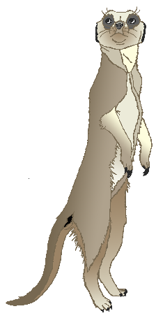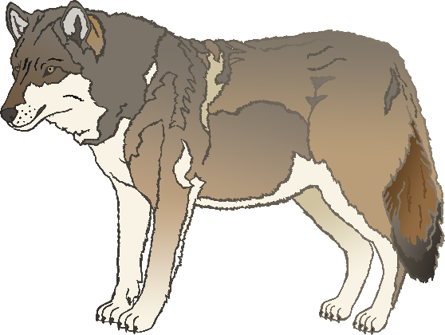

English/Spanish

cow

vaca

(ba-ca)

English/Spanish

meerkat

suricata

(soo-ree-cat-uh)

English/Spanish

zebra

cebra

(seh-bra)

or (th-eh-bra)

English/Spanish

horse

caballo

(car-bar-joh)

English/Spanish

pig

cerdo

(th-air-th-oh)

English/Spanish

goat

cabra

(car-bra)

English/Spanish

donkey

burro

(boo-roh)

English/Spanish

dog

perro

(p-air-oh)

English/Spanish

duck

pato

(pah-toh)

English/Spanish

goose

ganso

(gan-soh)

English/Spanish

sheep

oveja

(oh-vay-ha)

English/Spanish

chicken

gallina

(ga-jee-nah)

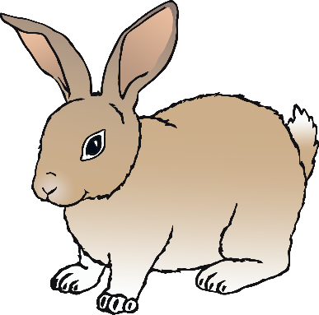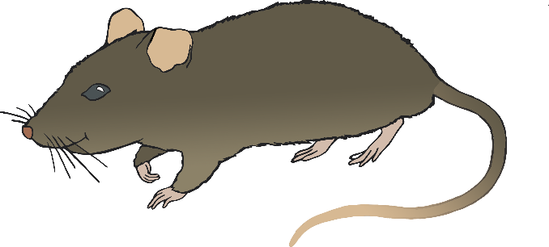

English/Spanish

bird

ave

(ar-vay)

English/Spanish

rabbit

conejo

(con-ay-hoh)

English/Spanish

rat

rata

(ra-ta)

English/Spanish

ox

buey

(b-oy)

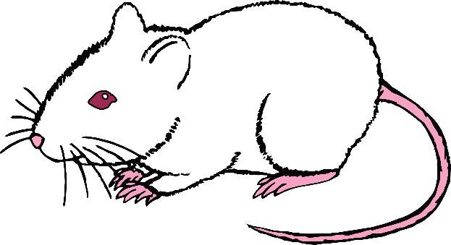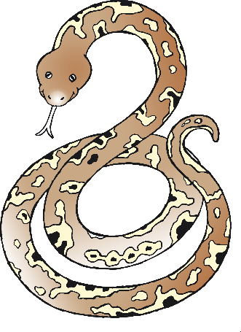

English/Spanish

cat

gato

(gat-oh)

English/Spanish

mouse

ratón

(rat-on)

English/Spanish

snake

serpiente

(sur-pee-en-tay)

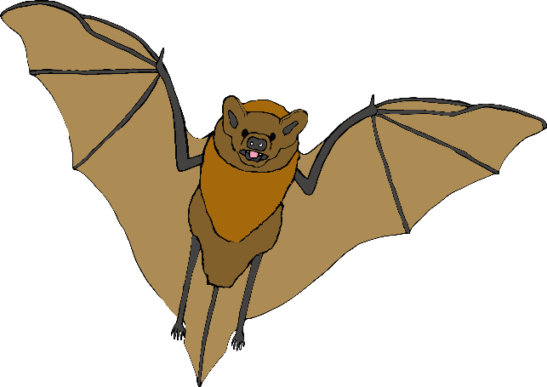

English/Spanish

bat

murciélago

(moor-thee-ah-lar-goh)

Or (moor-see-ah-lar-goh)

English/Spanish

squirrel

ardilla

(ar-thee-ah)

English/Spanish

fox

zorro

(th-oh-roh)

English/Spanish

hedgehog

erizo

(ay-ree-th-oh)

