English/Russian

www.littleowls-premium.com © 2019 Little Owls Resources

www.littleowls-premium.com © 2019 Little Owls Resources

www.littleowls-premium.com © 2019 Little Owls Resources

English/Russian

elephant

слон

(sl-or-n)

English/Russian

lion

лев

(lyev)

English/Russian

tiger

тигр

(teeg-r)

**Animal Cards**

English/Russian

giraffe

жираф

(zji-raff)

English/Russian

penguin

пингвин

(pen-gu-vin)

English/Russian

chimpanzee

шимпанзе

(shim-pan-z-air)

English/Russian

flamingo

фламинго

(flam-ing-ah)

English/Russian

komodo dragon

дракон комодо

(drak-on ko-moh-doh)

English/Russian

sea lion

морской лев

(mor-sk-oh-lyev)

English/Russian

rhinoceros

носорог

(noso-rok)

English/Russian

frog

лягушка

(l-yay-goosh-kah)

English/Russian

wolf

волк

(volk)

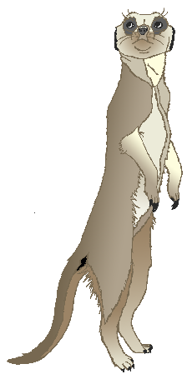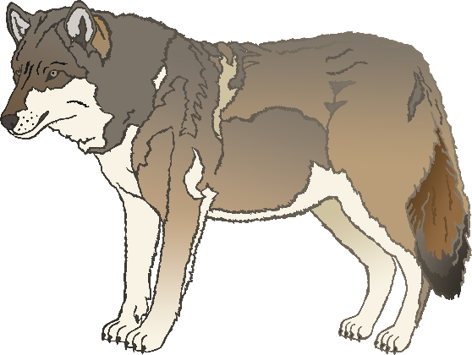

English/Russian

cow

корова

(ko-roh-vah)

English/Russian

meerkat

сурикат

(soo-ree-kat)

English/Russian

zebra

зебра

(zeh-bra)

English/Russian

horse

конь

(k-oh-n)

English/Russian

pig

свинья

(svin-ya)

English/Russian

goat

козел

(k-oh-zil)

English/Russian

donkey

осел

(oss-ill)

English/Russian

dog

собака

(soh-boh-ka)

English/Russian

duck

утка

(oot-ka)

English/Russian

goose

гусь

(goo-ss)

English/Russian

sheep

овца

(oft-sah)

English/Russian

chicken

курица

(koo-lit-sah)

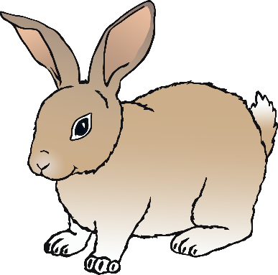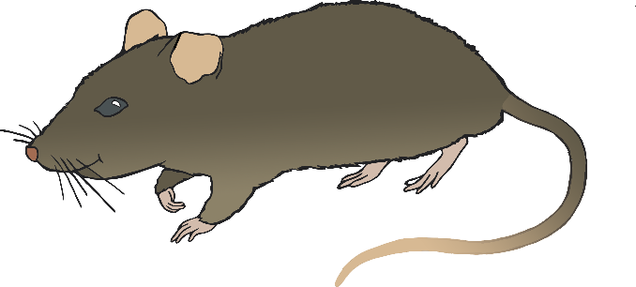

English/Russian

bird

птица

(p-tit-sah)

English/Russian

rabbit

кролик

(kroh-lik)

English/Russian

rat

крыса

(criss-ah)

English/Russian

ox

вол

(vol)

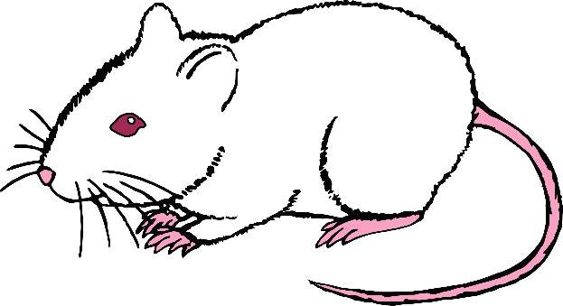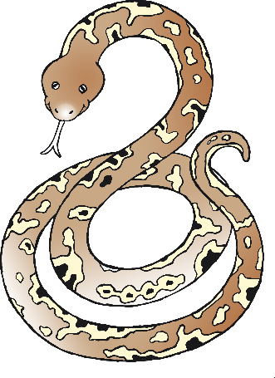

English/Russian

cat

кот

(kot)

English/Russian

mouse

мышь

(mish)

English/Russian

snake

змея

(zmee-ya)

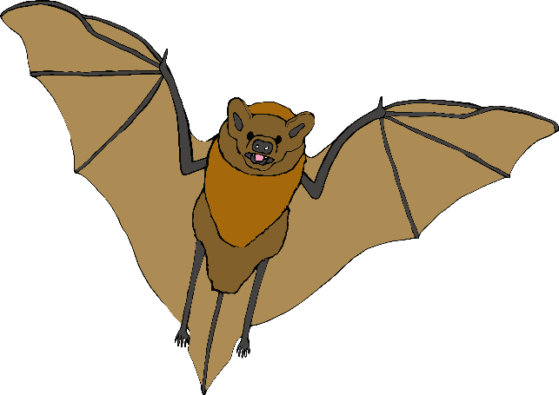

English/Russian

bat

летучая мышь (let-ooch-air mish)

English/Russian

squirrel

белка

(bill-kah)

English/Russian

fox

лиса

(lissa)

English/Russian

hedgehog

Ежик

(yo-zj-ik)

