© 2019 Little Owls Resources



www.littleowls-premium.com *EDITABLE Resource*

English/Punjabi

www.littleowls-premium.com © 2019 Little Owls Resources

www.littleowls-premium.com © 2019 Little Owls Resources

www.littleowls-premium.com © 2019 Little Owls Resources

English/Punjabi

elephant

ਹਾਥੀ

(hut-ee)

English/Punjabi

lion

ਸ਼ੇਰ

(sh-air)

English/Punjabi

tiger

ਬਾਘ

(barg)

**Animal Cards**

English/Punjabi

giraffe

ਜਿਰਾਫ਼

(jih-rarff)

English/Punjabi

penguin

ਪੈਨਗੁਇਨ

(peng-vin)

English/Punjabi

chimpanzee

ਚਿਮਪਾਨਜ਼ੀ

(chim-pan-zee)

English/Punjabi

flamingo

ਫਲੇਮਿੰਗੋ

(falem-ing-oh)

English/Punjabi

komodo dragon

ਕੋਮੋਡੋ ਡ੍ਰੈਗਨ

(ko-moh-doh drag-an-ah)

English/Punjabi

sea lion

ਸਮੁੰਦਰ ਦੇ ਸ਼ੇਰ

(tee-gr)

English/Punjabi

rhinoceros

ਗੈਂਡਾ

(gen-dah)

English/Punjabi

frog

ਡੱਡੂ

(da-doo)

English/Punjabi

wolf

ਬਘਿਆੜ

(bug-ee-ar-uh)

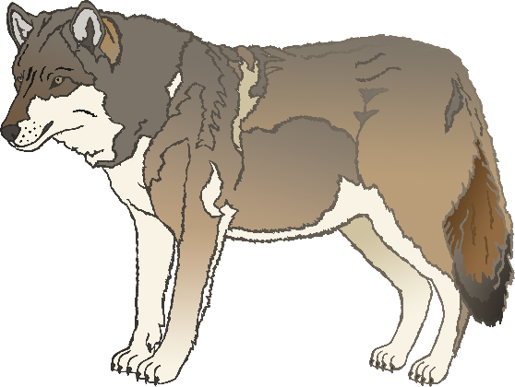

English/Punjabi

cow

ਗਾਂ

(gar)

English/Punjabi

zebra

ਜ਼ੇਬਰਾ

(jeh-brah)

English/Punjabi

horse

ਘੋੜਾ

(go-dah)

English/Punjabi

pig

ਸੂਰ

(soo-r)

English/Punjabi

goat

ਬੱਕਰੀ

(buk-a-ree)

English/Punjabi

donkey

ਖੋਤਾ

(kod-ah)

English/Punjabi

dog

ਕੁੱਤਾ

(goot-ah)

English/Punjabi

duck

ਬਤਖ਼

(bat-ak-ah)

English/Punjabi

goose

ਹੰਸ

(hass-uh)

English/Punjabi

sheep

ਭੇਡ

(b-air-d)

English/Punjabi

chicken

ਕੁਕੜੀ

(kook-a-dee)

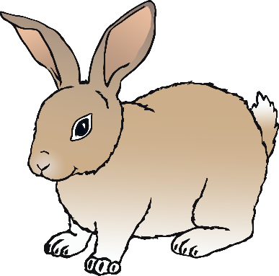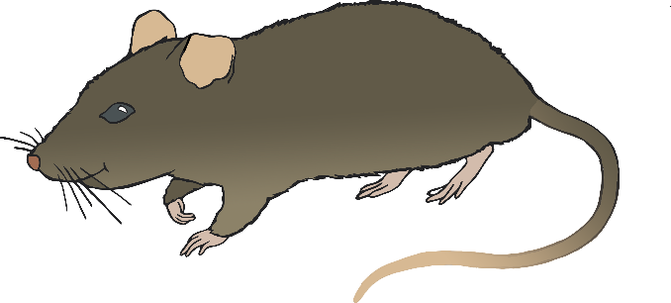

English/Punjabi

bird

ਪੰਛੀ

(puk-ee)

English/Punjabi

rabbit

ਖ਼ਰਗੋਸ਼

(k-air-gosh)

English/Punjabi

rat

ਚੂਹਾ

(choo-har)

English/Bengali

ox

ਬਲਦ

(bal-d)

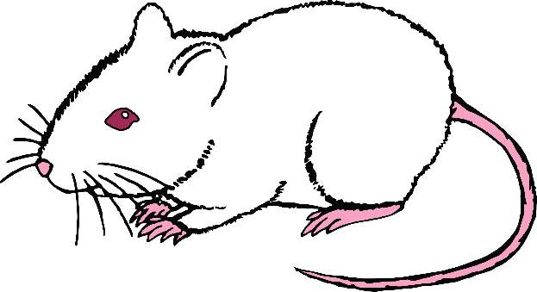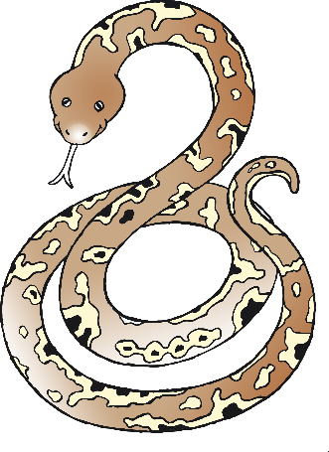

English/Bengali

cat

ਬਿੱਲੀ

(bil-ee)

English/Bengali

mouse

ਮਾਉਸ

(m-ou-ss)

English/Bengali

snake

ਸੱਪ

(sapp)

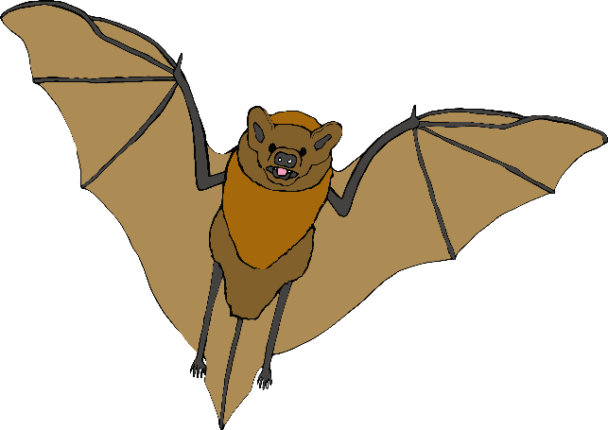

English/Punjabi

bat

चमगादੜ

(cham-ga-der)

English/Punjabi

squirrel

ਕਾਟੋ

(cart-oh)

English/Punjabi

fox

ਲੂਮੜੀ

(loom-ba-ree)

English/Punjabi

hedgehog

ਹੇਜਹੌਗ

(heja-hoga)

