© 2019 Little Owls Resources



www.littleowls-premium.com *EDITABLE Resource*

English/Portuguese

www.littleowls-premium.com © 2019 Little Owls Resources

www.littleowls-premium.com © 2019 Little Owls Resources

English/Portuguese

elephant

elefante

(ell-eh-fun-t)

English/Portuguese

lion

leão

(lay-oh)

www.littleowls-premium.com © 2019 Little Owls Resources

English/Portuguese

tiger

tigre

(tee-gr)

**Animal Cards**

English/Portuguese

giraffe

girafa

(jzi-raffa)

English/Portuguese

penguin

pinguim

(ping-wing)

English/Portuguese

chimpanzee

chimpanzé (shim-pan-zeh)

English/Portuguese

flamingo

flamingo

(flam-ing-oh)

English/Portuguese

komodo dragon

dragão de komodo

(drag-oh-ji-ko-moh-doh)

English/Portuguese

sea lion

tigre

(lay-oh mar-ee-noh)

English/Portuguese

rhinoceros

rinoceronte

(ree-noh-seh-ron-ter)

English/Portuguese

frog

sapo

(sah-poh)

English/Portuguese

wolf

lobo

(lo-boh)

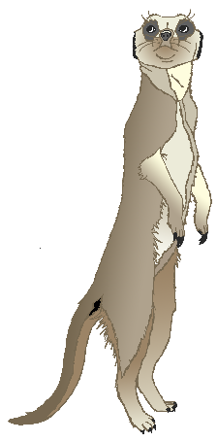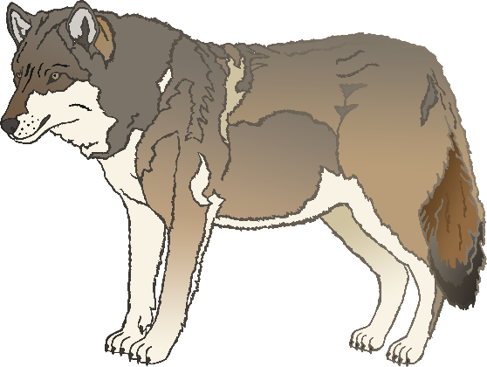

English/Portuguese

cow

vaca

(vah-cah)

English/Portuguese

meerkat

meerkat

(meer-kah)

English/Portuguese

zebra

zebra

(zeh-brah)

English/Portuguese

horse

cavalo

(ka-var-loh)

English/Portuguese

pig

porco

(por-koh)

English/Portuguese

goat

cabra

(car-brah)

English/Portuguese

donkey

burro

(boo-hoo)

English/Portuguese

dog

cão

(k-ou)

English/Portuguese

duck

pato

(pah-toh)

English/Portuguese

goose

ganso

(gan-soh)

English/Portuguese

sheep

ovelha

(or-v-eye-la)

English/Portuguese

chicken

galinha

(gal-ee-nah)

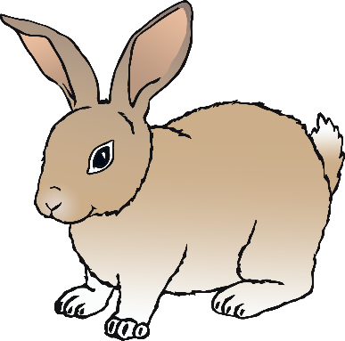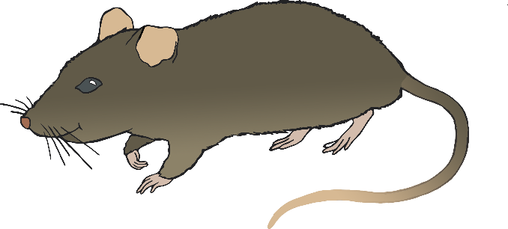

English/Portuguese

bird

ave

(arv-uh)

English/Portuguese

rabbit

coelho

(coh-ell-oh)

English/Portuguese

rat

rato

(hat-oh)

English/Portuguese

ox

boi

(b-oy)

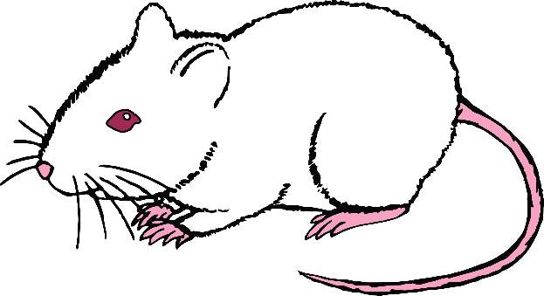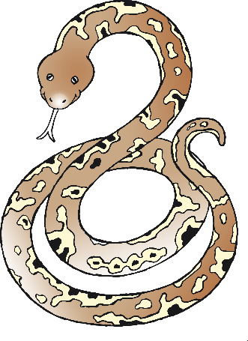

English/Portuguese

cat

gato

(gah-toh)

English/Portuguese

mouse

mouse

(m-ou-ss)

English/Portuguese

snake

serpente

(sur-pent-uh)

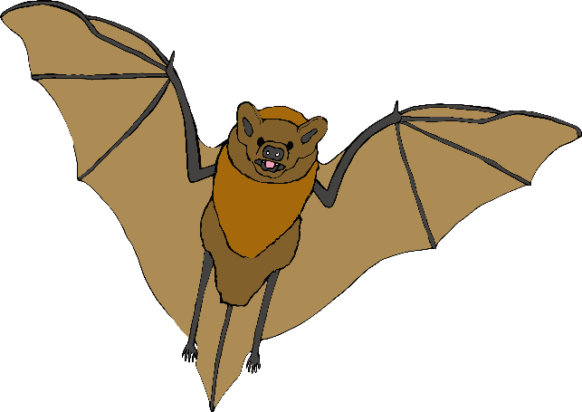

English/Portuguese

bat

morcego

(mur-say-goh)

English/Portuguese

squirrel

esquillo

(esh-kee-loh)

English/Portuguese

fox

raposa

(rap-oh-zah)

English/Portuguese

hedgehog

porco-espinho

(pork-esh-pee-noh)

