© 2019 Little Owls Resources



www.littleowls-premium.com *EDITABLE Resource*

English/Polish

**Animal Cards**

www.littleowls-premium.com © 2019 Little Owls Resources

www.littleowls-premium.com © 2019 Little Owls Resources

www.littleowls-premium.com © 2019 Little Owls Resources

English/Polish

elephant

słoń

(swon-yuh)

English/Polish

lion

lew

(leff)

English/Polish

tiger

tygrys

(tig-riss)

English/Polish

giraffe

żyrafa

(ji-raffa)

English/Polish

penguin

pingwin

(ping-vin)

English/Polish

chimpanzee

szympans

(shim-pan-ss)

English/Polish

flamingo

flaming

(flam-ing)

English/Polish

komodo dragon

waran z komodo

(vah-rants-ko-moh-doh)

English/Polish

sea lion

lew morski

(leff-mor-skee)

English/Polish

rhinoceros

nosorożec

(noss-oh-ro-jzets)

English/Polish

frog

żaba

(jz-ub-uh)

English/Polish

wolf

wilk

(vilk)

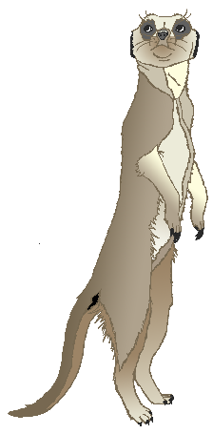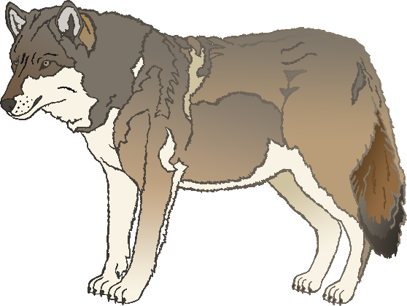

English/Polish

cow

krowa

(krow-vah)

English/Polish

meerkat

surykatka

(soo-ree-kat-kah)

English/Polish

zebra

zebra

(zeh-brah)

English/Polish

horse

koń

(kon)

English/Polish

pig

świnia

(sh-fin-ya)

English/Polish

goat

koza

(ko-zah)

English/Polish

donkey

osioł

(oh-show)

English/Polish

dog

pies

(pyess)

English/Polish

duck

kaczka

(ka-ch-ka

English/Polish

goose

gęś

(tee-gr)

English/Polish

sheep

owca

(offt-sah)

English/Polish

chicken

kura

(koo-rah)

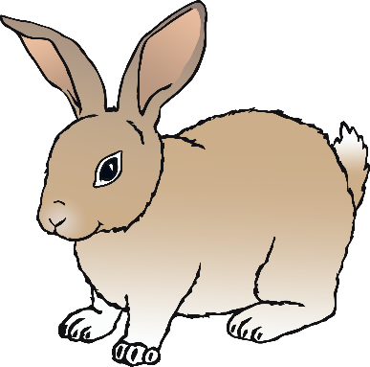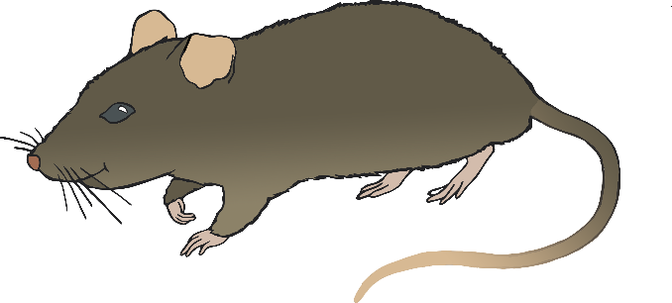

English/Polish

bird

ptak

(p-tak)

English/Polish

rabbit

królik

(krow-lik)

English/Polish

rat

szczur

(sh-toor)

English/Polish

ox

wół

(v-oh)

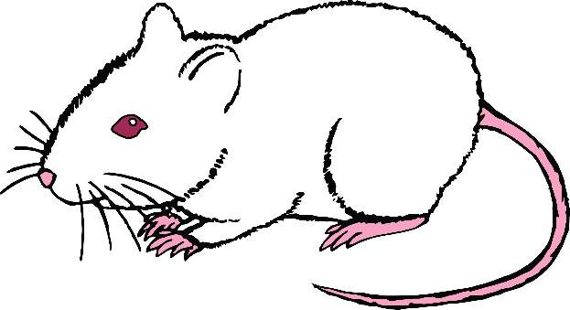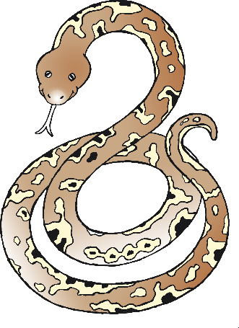

English/Polish

cat

kot

(kot)

English/Polish

mouse

mysz

(mish)

English/Polish

snake

wąż

(voh-jz)

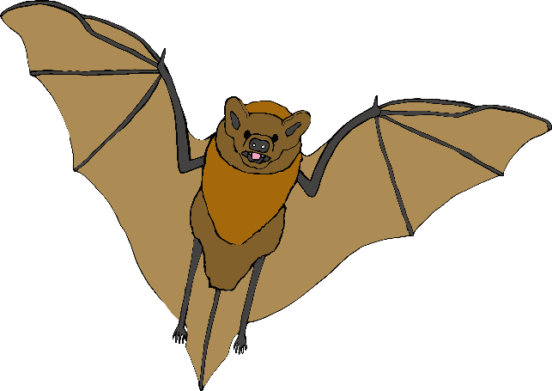

English/Polish

bat

nietoperz

(nyi-top-esh)

English/Polish

squirrel

wiewiórka (vyair-vyor-kar)

English/Polish

fox

lis

(lee-ss)

English/Polish

hedgehog

jeż

(ye-jz)

