© 2019 Little Owls Resources



www.littleowls-premium.com *EDITABLE Resource*

English/Malay

www.littleowls-premium.com © 2019 Little Owls Resources

www.littleowls-premium.com © 2019 Little Owls Resources

www.littleowls-premium.com © 2019 Little Owls Resources

English/Malay

elephant

gajah

(gar-jah)

English/Malay

lion

singa

(seen-guh)

English/Malay

tiger

harimau

(har-ee-m-ou)

**Animal Cards**

English/Malay

giraffe

zirafah

(zee-raffa)

English/Malay

penguin

burung penguin

(boo-rrng pen-gwin)

English/Malay

chimpanzee

cimpanzi

(chim-pan-zee)

English/Malay

flamingo

flamingo

(flam-in-goh)

English/Malay

komodo dragon

naga komodo

(na-ga ko-moh-doh)

English/Malay

sea lion

singa laut

(seen-guh l-oht)

English/Malay

rhinoceros

badak sumbu

(badak-soom-boo)

English/Malay

frog

katak

(ka-tak)

English/Malay

wolf

serigala

(sur-ee-ga-la)

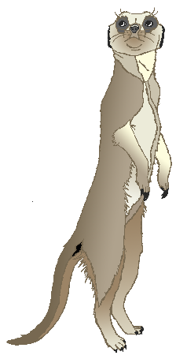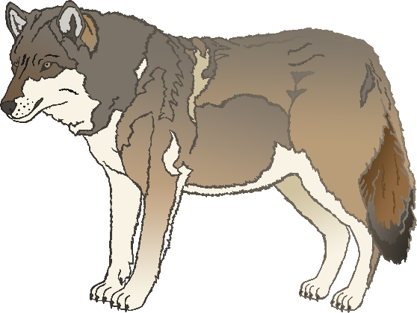

English/Malay

cow

lembu

(lem-boo)

English/Malay

meerkat

meerkat

(meer-kat)

English/Malay

zebra

kuda belang

(koo-dur b-lung)

English/Malay

horse

kuda

(koo-dur)

English/Malay

pig

khinzir

(kin-zeer)

English/Malay

goat

kambing

(kam-bing)

English/Malay

donkey

keldai

(cul-d-eye)

English/Malay

dog

anjing

(an-jing)

English/Malay

duck

itik

(ee-tik)

English/Malay

goose

angsa

(ang-sur)

English/Malay

sheep

kambing biri-biri

(kam-bing-bih-ree-bi-ree)

English/Malay

chicken

ayem

(eye-arm)

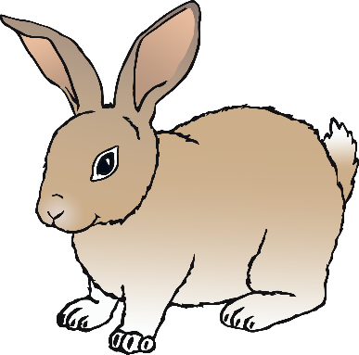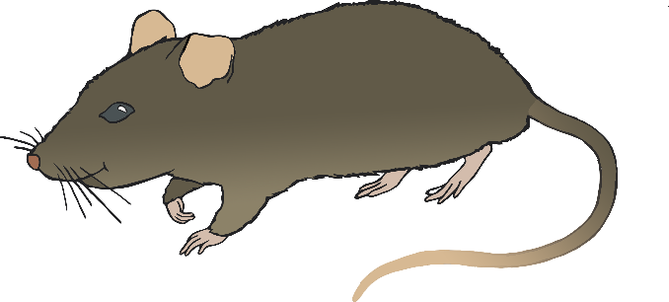

English/Malay

bird

burung

(boo-rrng)

English/Malay

rabbit

arnab

(ar-nub)

English/Malay

rat

tikus

(tik-ooss)

English/Malay

ox

seladang

(sur-lad-ung)

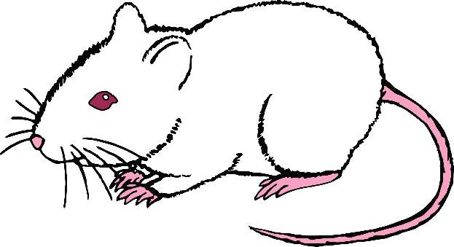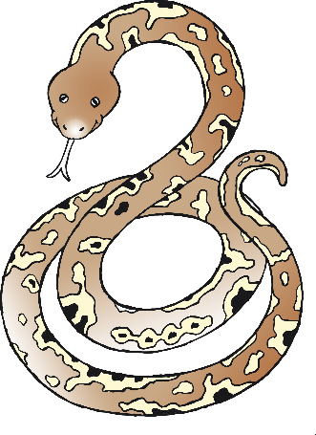

English/Malay

cat

kucing

(koo-ching)

English/Malay

mouse

tetikus

(tet-ee-kooss)

English/Malay

snake

ular

(oo-lar)

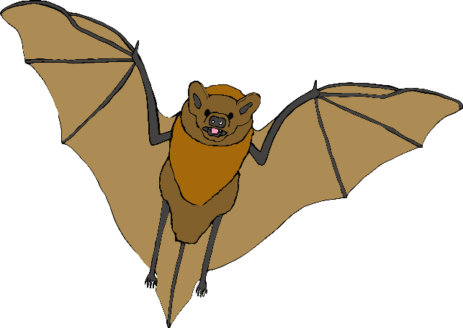

English/Malay

bat

kelawar

(kur-la-wa)

English/Malay

squirrel

tupai

(too-p-eye)

English/Malay

fox

musang

(moo-sang)

English/Malay

hedgehog

landak

(lan-duk)

