© 2019 Little Owls Resources



www.littleowls-premium.com *EDITABLE Resource*

English/Japanese

**Animal Cards**

English/Japanese

elephant

ぞう

(z-oh)

English/Japanese

lion

らいおん

(r-eye-on)

English/Japanese

tiger

とら

(toh-ra)

English/Japanese

giraffe

きりん

(kih-reen)

English/Japanese

penguin

ぺんぎん

(peng-in)

English/Japanese

chimpanzee

ちんぱんじー(chin-pan-jee)

English/Japanese

flamingo

ふらみんご(foo-rah-meen-goh)

English/Japanese

komodo dragon

こもどどらごん

(ko-moh-doh-dor-a-gon)

English/Japanese

sea lion

あしか

(ash-ee-kah)

English/Japanese

rhinoceros

さい

(s-eye)

English/Japanese

frog

かえる

(k-eye-roo)

English/Japanese

wolf

おおかみ

(oh-kar-mee)

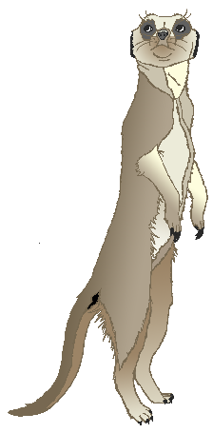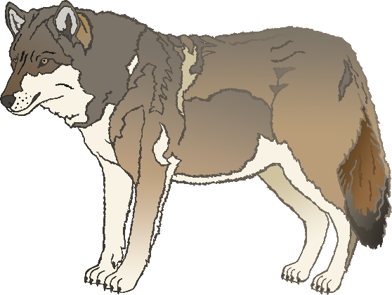

English/Japanese

cow

うし

(oo-shee)

English/Japanese

zebra

しまうま

(shee-mou-mah)

English/Japanese

meerkat

みーあきゃっと

(mee-ah-kat-oh)

English/Japanese

horse

うま

(oo-mah)

English/Japanese

pig

ぶた

(boo-tah)

English/Japanese

goat

やぎ

(yag-ee)

English/Japanese

donkey

ろば

(roh-bah)

English/Japanese

dog

いぬ

(ee-nuh)

English/Japanese

duck

あひる

(ah-hee-roo)

English/Japanese

goose

がちょう

(ga-ch-oa)

English/Japanese

sheep

ひつじ

(hit-soo-jee)

English/Japanese

chicken

ちきん

(ch-ik-een)

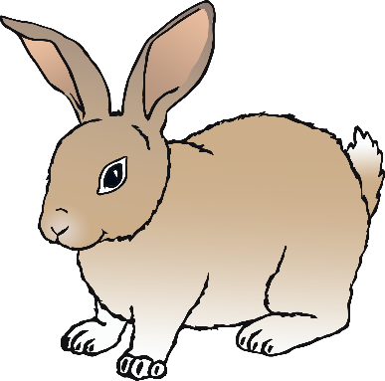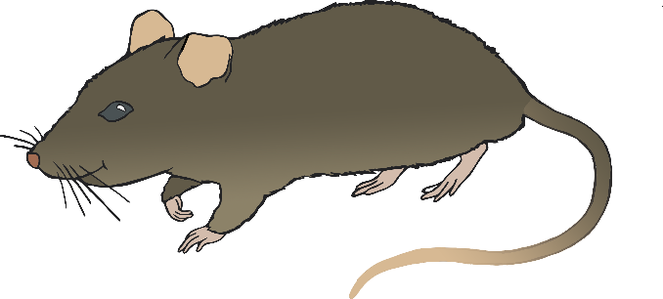

English/Japanese

bird

とり

(toh-ree)

English/Japanese

rabbit

うさぎ

(oo-sar)

English/Japanese

rat

ねずみ

(neh-zoo-mee)

English/Japanese

ox

おうし

(oh-shee)

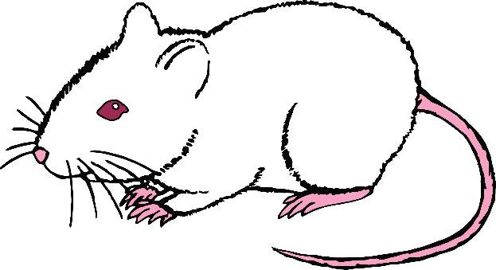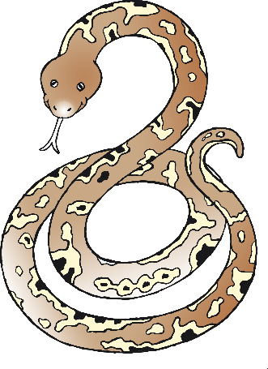

English/Japanese

cat

ねこ

(neh-k-oh)

English/Japanese

mouse

ねずみ

(neh-zoo-mee)

English/Japanese

snake

へび

(heh-bee)

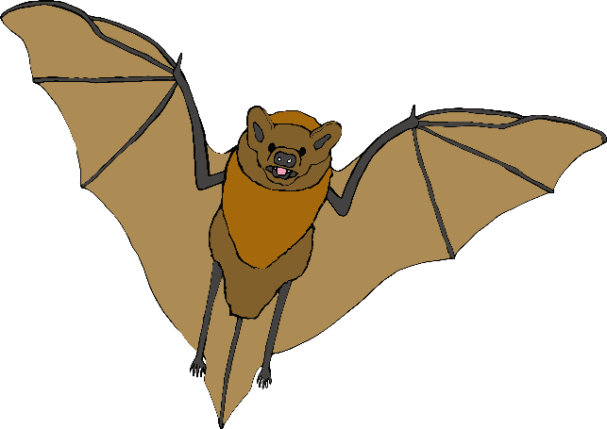

English/Japanese

bat

こうもり

(koh-moh-ree)

English/Japanese

squirrel

りす

(ree-soo)

English/Japanese

fox

きつね

(kit-zoo-neh)

English/Japanese

hedgehog

はりねずみ

(ha-ree-neh-zoo-mee)

