English/Italian

www.littleowls-premium.com © 2019 Little Owls Resources

www.littleowls-premium.com © 2019 Little Owls Resources

www.littleowls-premium.com © 2019 Little Owls Resources

English/Italian

elephant

elefante

(ell-eh-fant-ay)

English/Italian

lion

leone

(lay-oh-nay)

English/Italian

tiger

tigre

(tee-gray)

**Animal Cards**

English/Italian

giraffe

giraffa

(ji-raffa)

English/Italian

penguin

pinguino

(pin-gween-oh)

English/Italian

chimpanzee

scimpanzé (shim-pun-say)

English/Italian

flamingo

fenicottero

(fen-ee-cort-eh-roh)

English/Italian

komodo dragon

drago di komodo

(dra-go-dee-ko-moh-doh)

English/Italian

sea lion

leone marino

(lay-oh-nay ma-ree-noh)

English/Italian

rhinoceros

rinoceronte

(ree-noh-chair-on-tay)

English/Italian

frog

rana

(rah-nah)

English/Italian

wolf

lupo

(loo-poh)

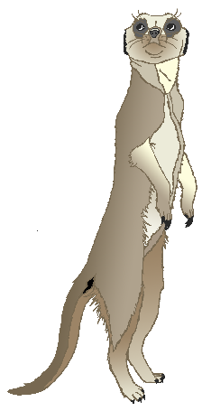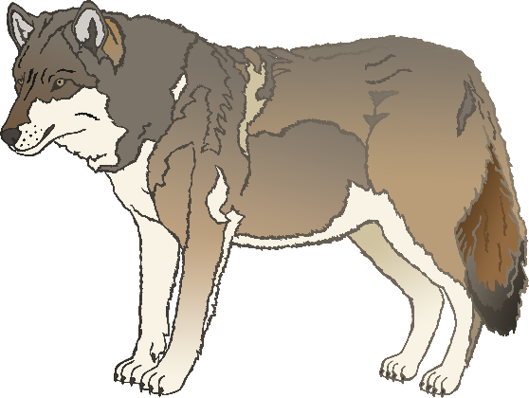

English/Italian

cow

mucca

(moo-kah)

English/Italian

meerkat

meerkat

(meer-katah)

English/Italian

zebra

zebra

(zeh-brah)

English/Italian

horse

cavallo

(cah-vall-oh)

English/Italian

pig

maiale

(my-ah-lay)

English/Italian

goat

capra

(cap-rah)

English/Italian

donkey

asino

(az-ee-noh)

English/Italian

dog

cane

(car-nay)

English/Italian

duck

anatra

(ana-trah)

English/Italian

goose

oca

(oh-kah)

English/Italian

sheep

pecora

(pec-or-uh)

English/Italian

chicken

pollo

(p-or-loh)

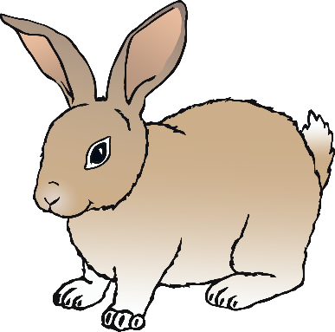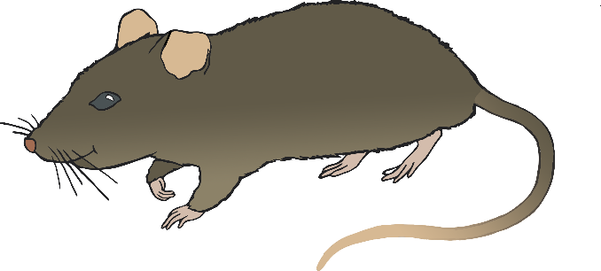

English/Italian

bird

uccello

(oo-chell-oh)

English/Italian

rabbit

coniglio

(koh-nee-lee-oh)

English/Italian

rat

ratto

(rat-oh)

English/Italian

ox

bue

(boo-ay)

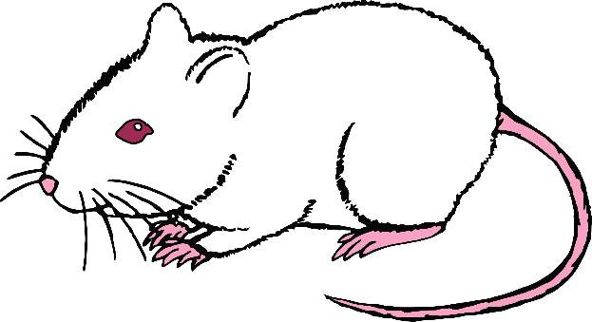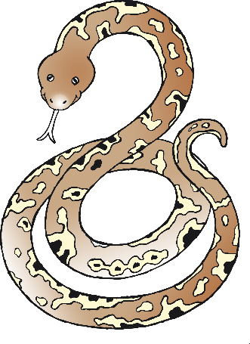

English/Italian

cat

gatto

(gat-oh)

English/Italian

mouse

mouse

(m-ou-ss)

English/Italian

snake

serpente

(sair-pen-tay)

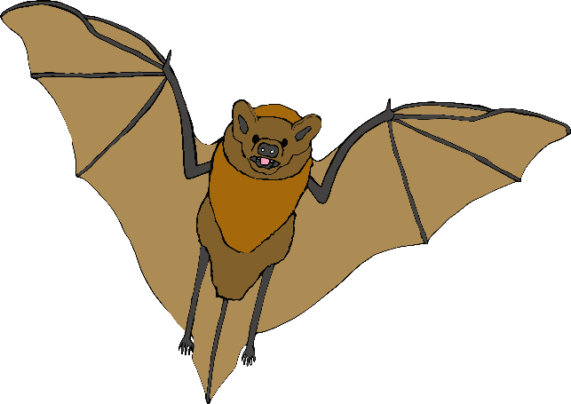

English/Italian

bat

pipistrello

(pee-pee-strell-oh)

English/Italian

squirrel

scoiattolo

(sk-oy-at-oh-loh)

English/Italian

fox

volpe

(vol-pay)

English/Italian

hedgehog

riccio

(ree-ch-oh)

