© 2019 Little Owls Resources



www.littleowls-premium.com *EDITABLE Resource*

English/German

www.littleowls-premium.com © 2019 Little Owls Resources

www.littleowls-premium.com © 2019 Little Owls Resources

www.littleowls-premium.com © 2019 Little Owls Resources

English/German

elephant

Elefant

(eh-leh-fant)

English/German

lion

Löwe

(lur-vah)

English/German

tiger

Tiger

(tee-gar)

**Animal Cards**

English/German

giraffe

Giraffe

(gih-raffa)

English/German

penguin

Pinguin

(pin-goo-in)

English/German

chimpanzee

Schimpanse

(shim-pan-zuh)

English/German

flamingo

Flamingo

(flam-in-go)

English/German

komodo dragon

Komodo-Drache

(ko-moh-do-dracch-uh)

English/German

sea lion

Seelöwe

(zee-lur-vah)

English/German

rhinoceros

Nashorn

(narz-horn)

English/German

frog

Frosch

(frosh)

English/German

wolf

Wolf

(volff)

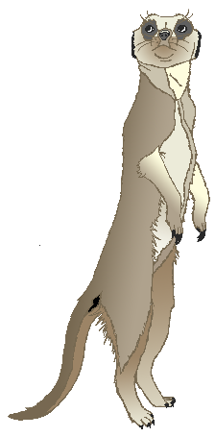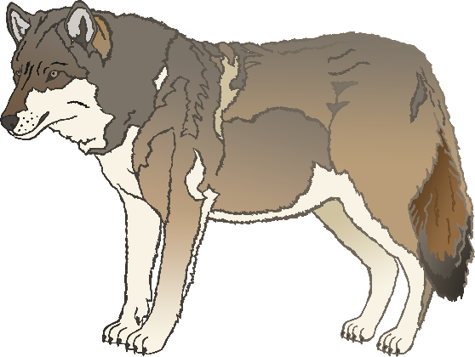

English/German

cow

Kuh

(coo)

English/German

meerkat

Erdmännchen

(erd-menk-yun)

English/German

zebra

Zebra

(zay-bra)

English/German

horse

Pferd

(fairt)

English/German

pig

Schwein

(shv-eye-n)

English/German

goat

Ziege

(zee-gah)

English/German

donkey

Esel

(ee-zll)

English/German

dog

Hund

(hoo-nt)

English/German

duck

Ente

(ent-uh)

English/German

goose

Gans

(gun-ss)

English/German

sheep

Schaf

(sharf)

English/German

chicken

Huhn

(hoon)

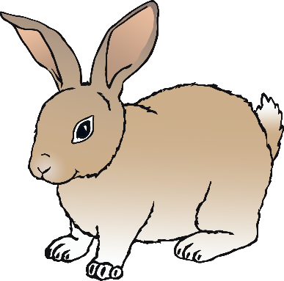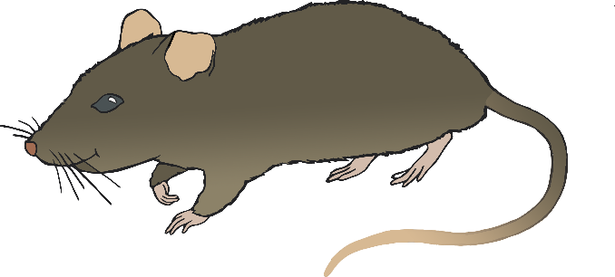

English/German

bird

Vogel

(foh-gul)

English/German

rabbit

Kaninchen

(kan-in-cyun)

English/German

rat

Ratte

(rat-uh)

English/German

ox

Ochse

(ox-uh)

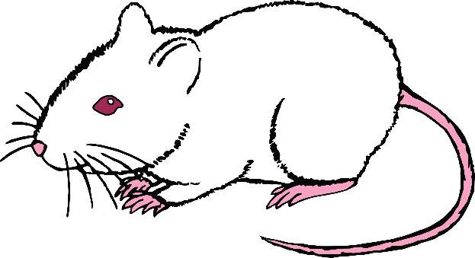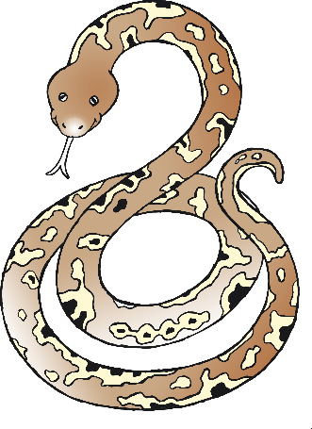

English/German

cat

Katze

(cat-zuh)

English/German

mouse

Maus

(m-ou-ss)

English/German

snake

Schlange

(sh-lang-uh)

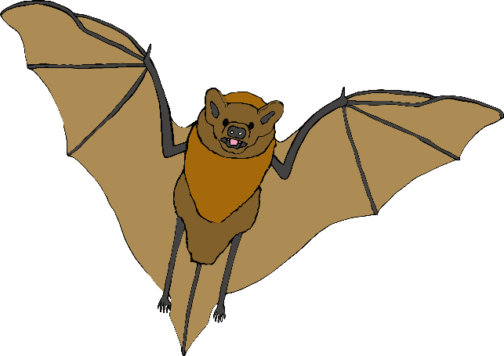

English/German

bat

Fledermaus

(flay-dah-m-ou-ss)

English/German

squirrel

Eichhörnchen

(eye-kyon-kyen)

English/German

fox

Fuchs

(f-ox)

English/German

hedgehog

Igel

(ee-gul)

